**A Project Report On**

**“*Online Shopping System”* Submitted to**

**Vidyasagar University**

**for the partial**

**Fulfillment of the Requirement for the Award of the Degree of Bachelor of Computer Application (BCA)**



**Submitted By**

### Writtik Bhattacharya

*Roll: 46118106 No.026*

Reg. No: *0000060* of Year: 2018-2019

### Debraj Maity

*Roll: 46118106 No.004*

Reg. No: *0000038* of Year: 2018-2019

### Ayesha Khatun

*Roll: 46118106 No.003*

Reg. No: *0000037* of Year: 2018-2019

**Piyali Das**

*Roll: 46118106 No.009*

Reg. No: 0000043 of Year: 2018-2019

**DEPARTMENT OFCOMPUTER APPICATION**

Debra Thana Sahid Kshudiram Smriti Mahavidyalaya

Gangaramchak, P.O.: Chakshyampur, District: Paschim Medinipur, PIN: 721124.

Debra Thana Sahid Kshudiram Smriti Mahavidyalaya



Gangaramchak, P.O.: Chakshyampur, District: Paschim Medinipur, PIN: 721124.

**Department of Computer Appcication**

**Self Declaration Certificate**

This is to certify that dissertation/Project Proposal entitled “**Online**

**Shopping System ”**  submitted by **Writtik Bhattacharya, Debraj Maity, Ayesha Khatun and Piyali Das** is an Authentic work carried out for the partial fulfillment of the requirements for the award of the certificate of project by Debra Thana Sahid Kshudiram Smriti Mahavidyalaya, Paschim

Medinipur under the guidance **Prof.** **Amita Samanta Adhya.** The matter embodied in this project work has not been submitted earlier for award of any certificate to the best of our knowledge and belief.

……………………………………

**Date: 11/08/2021 Writtik Bhattacharya**

**Debraj Maity Ayesha Khatun Piyali Das**

Debra Thana Sahid Kshudiram Smriti Mahavidyalaya



Gangaramchak, P.O.: Chakshyampur, District: Paschim Medinipur, PIN: 721124.

# Department of Computer Appcication

Project Report

On

“**Online Shopping System”**

**CERTIFICATE BY GUIDE**

This is to certify that this project entitled “**Online Shopping System**” submitted by **Writtik Bhattacharya, Debraj Maity, Ayesha Khatun and Piyali Das** as a partial fulfillment of the certificate of project by **Debra Thana Sahid Kshudiram Smriti Mahavidyalaya** done by the group members is an authentic work carried out under my guidance and best of our knowledge and belief.

**Date: 11/08/2021**

**.......................................... Prof.** **Amita Samanta Adhya**

**Project Guide**

**DTSKS Mahavidyalaya**

✪ **Index:**

*Introduction of a project……………………………………………………………………………………………………………. 2 Project group and responsibility………………………………………………………………………………………………… 3 Acknowledgements……………………………………………………………………………………………………………………. 4 Preface………………………………………………………………………………………………………………………………………. 5 Student Declaration…………………………………………………………………………………………………………..………. 5*

*Create by / Guide by………………………………………………………………………………………………………………….. 5*

*Project Objectives …………………………………………………………………………………………………………………….. 6*

*About the Project…..………………………………………………………………………………………………………………….. 7 H/w and s/w specification or the requirement ………………………………………………………………………… 8*

*Tools and Technique …………………………………………………………………………………………………………………. 9 Database………………………………………………………………………………………………………………………… 9 SQL Server 2008………………………………..…………………………………………………………………………… 9*

*Asp.Net……………………………………….………………………………………………………………………………….. 9-10*

*Table………………….………………………………………………………………………………………………………….. 10 Feasibility Study……………………………………………………………………………………………………………..…………. 12*

*Software Engineering Tools………………………………………………………………………………………………………. 13*

*Waterfall model……………………………………………………………………………………………………………………….. 13-14*

*Project Description……………………..………………………………………………………........................................ 15*

*Data Flow Diagram………………………………..…………………………………………………………………………………. 16-19 Database Table Schema……………….…………………………………………………………………………………………… 10-12 ER Diagram…………………………………………..………………………………………………………………………………….. 20*

*Project Layout and Project Code…..…………………………………………………………………………………………. 21-33*

*User Manual……………..……………………………………………………………………………………………………………… 34 Scope For Improvement……………………………………………………………………………………………………………. 35 Conclusion……………………………………………………………………………………………………………………………….. 36 Bibliography…………………………………………………………………………………………………………………………….. 37*

=============================== ================================

**INTRODUCTION OF PROJECT:**

**T**his project comprises of an efficient and user-friendly Web design for **Online Shopping**

**System**.

It provides users the details regarding the any types of products launched in the market by various companies.

It also provides users the details regarding the updating in the previously launched products and also the various schemes and discounts the companies offer for their products.

The overall work is divided among two users-administrator and user/customer thus making the system to work smoothly, effectively and efficiently.

It aims of minimizing the manual labor and errors by making the overall system computerized.

The project I are willing to discuss about is computerized **Online Shopping System**. Today this software is very much useful. This software does certain tasks related to the day-to-day management activities, thus taking away some pressure off the management personnel. This project is an application created on the basis of the Client-Server Architecture to serve the purpose of automation of the information of ship, information of container, booking, etc over a number of branches of a shipping agency irrespective of the geographical location of the place from where the user or client are interested to work. The online feature makes the **Online Shopping System** seem like being performed in a single branch.

**PROJECT GROUP AND RESPONSIBILITY:**

**T**o give **Online Shopping System** its form that it represents, it was an honest effort of a group of four people teaming up together for nearly six months, namely **Writtik Bhattacharya, Debraj Maity,Ayesha Khatun and Piyali Das .** It is because of the entire team effort that **Online Shopping System** has it presentable form.

Starting from the scratch, the entire project was divided into modules that respective group members had performed. For the modules work the person with the responsibility had performed information gathering to coding, testing and maintenance.

The following list shows the responsibilities shared by the respective persons

**Writtik Bhattacharya: -** I was responsible for the whole design of the project, also helps other’s member of the project. The system first checks for valid ID and Password of the Administrator and Member. Then I can search Member, Administrator. Also, here Administrator can Insert Update, Delete product, customer, booking, etc. ,also Member Information and Machine information.

**Debraj Maity: -** I was responsible for the code of the project. The system first checks for valid ID and Password of the Administrator and Member. Then I can search Member, Administrator. Also, here Administrator can Insert Update, Delete product, customer, booking ,etc ,also Member Information and Machine information.

**Ayesha Khatun: -** I was responsible for the requirement analysis, testing, maintenance, etc also helps code of the project. The system first checks for valid ID and Password of the Administrator and Member. Then I can search Member, Administrator. Also, here Administrator can Insert Update, Delete product, customer, booking,etc ,also Member Information and Machine information.

**Piyali Das : -** I was responsible for the requirement analysis, testing, maintenance, etc also helps code of the project. The system first checks for valid ID and Password of the Administrator and Member. Then I can search Member, Administrator. Also, here Administrator can Insert Update, Delete product, customer, booking, etc ,also Member Information and Machine information.

**Prof. Amita Samanta Adhya: -** She was responsible for the coding of the project. *The system first checks for valid ID and Password* of the Administrator and User, then I can search items, buy items, submit order and I can send complain about items if any. Also here Administrator can Insert, Update, Delete customer Information and items information.

A User who send request for buy items, Administrator can accept the request. He has the major responsibility for designing the forms.

**ACKNOWLEDGEMENTS:**

**A**ny work small or big is always a tough ask for a sole individual to get it correct working as per the requirements. Ours was also not any different. I would first thank our project center **Debra Thana Sahid Kshudiram Smriti Mahavidyalaya** where I was trained with the updated technologies of Server2007 architecture and the all the techniques that Ire required for the fulfillment of this project.

I would like to thank our project guide **Amita Samanta Adhya** who had rendered his valuable guidance throughout of our project. Without his guidance this project would have been where it is today.

Friends in need are friends in deed --- a phrase heard of many but would really suit to all our classmates who had by our side throughout our task rendering their support and help.

I would like to thank our College Management, Faculties and all others for giving us the opportunity to learn and deploy our skills in the field of online project.

I acknowledge all the above mentioned for the direct or indirect help in our endeavor. Last but not the least I would thank all my Project Partners for being like a family and doing this uphill task and supporting each other in times of difficulties and need.

**Thanking You. With best regards.**

**Writtik Bhattacharya**

**Debraj Maity**

**Ayesha Khatun**

**Piyali Das**

**PREFACE:**

**M**ankind has made huge progress in science and technology and as a result, we are now in the dawn of a new era. The computer is the first “Memory soaring brain machine” of this development. For the first time, our society is keyed to information resource that is renewable and self-generating. Today’s computers give us the information we need largely and they are very helpful when used in any project design.

A software project a set of activities , which comprise development of software tools in order to a problem defined by the requirement analysis, feasibility study, system analysis, system design and implement to achieve reliable user friendly software.

✪ **STUDENT DECLARATION:**

**I** hereby declare that this project report entitled **“ONLINE SHOPPING SYSTEM”** has been prepared by me under the guidance Of **Amita Samanta Adhya**, lecturer of computer Application department of Debra Thana Sahid Kshudiram Smriti Mahavidyalaya **,** In partial fulfillment of the requirement of the award of degree BCA by Vidyanagar university.

I would like to declare that this is the result of my own effort and that it has not been satisfied to any College or to other boards for the award of degree.

### Prepared By:

**Writtik Bhattacharya**

### Debraj Maity

### Ayesha Khatun

### Piyali Das

**DTSKS Mahavidyalaya**

* **CREDITS BY:**

* + ***Writtik Bhattacharya***
  + **Debraj Maity**
  + **Ayesha Khatun** ❖ **Piyali Das**
* **PROJECT GUIDE:**

❖ **Prof. Amita Samanta Adhya**

## PROJECT OBJECTIVE:

**Q**uite a few packages for various kinds of management issues in the market now days. Among them some are very good while some are clumsy and awkward to use, not to mention their user unfriendliness.

I in my project have tried to bring up packages, which can handle to a sample of **ONLINE SHOPPING SYSTEM .** This software mainly used for those machines which does not contain any keyboard. But in Online Shopping System, you can see outputs through hand gadgets . This software initially used for any types of product shopping purpose. We hope this software might be very popular for those customers who have to make their online shopping and who want to be make their delivery at home premises to touch the next generation by keep the hand of computer.

We try to my best to make the package as user friendly as possible and mainly local needs available.

**ABOUT THE PROJECT:**

**T**he project “**ONLINE SHOPPING SYSTEM** ” is an application based on the basis of the SQLServer architecture. In this application you send a request from the client side to the server side and the server satisfies the request from the client side.

Being an application based on the Client-Server architecture our application has the front end developed in sql server side scripting language name .NET and has the back end in the form of SQL Server.

It is divided in to eight parts mainly-----

**Admin Login**

**Account**

**product type**

**Booking**

**Feedback**

**Member registration**

**Member login**

**Forget password**

**Module Description:**

**Admin login:** The administrator can login from their Id and password. The administrator login enters the inner part of the project. Once a person logs in with the administrator criteria he can update, delete, and insert in the product database, booking database. Also shows customer database feedback database. This login has been kept under tight scanner.

**Account: - T**here are two types of account that we have provided with namely ADMINISTRATOR and customer. The administrator can login and update his account when needed from their Admin database. The customer can login and update his account when needed from their customer database

**Product type : - T**here are many types of product available our website that search by customer which is choose his/her product.

**Booking: - T**here are many types of products available our website that search by customer which is choose his/her needed and booked them. Here multiple products booking facility available at a time.

**Feedback: - A**t fast the page and customer page define feedback option where any types of customers write his/her own valuable feedback that need to be any customer and upgradation of administrator. After that administrator reply when needed.

**Customer registration: - T**he user/customer first register details our website where data will be fully secure. After registration, login our website and access it.

**Customer login:** The Customer can login from their Id and password. The Customer login enters the clint/outer part of the project. Once a person logs in with the customer criteria he can choose skin from the skin database, tips database. Also submit own valuable feedback in to the feedback database. This login has been kept under tight scanner.

**Forget password:** Here two types of forget password option admin forget password and customer forget password which is fully live webserver. Here first securely send OTP into valid email address then put it into proper event when it true finally retrieve password.

##  HARDWARE AND SOFTWARE REQUIREMENT SPECIFICATION:

❖ **Hardware Requirements(minimum)**

The software developed will run on any Client /Server environment.

The Minimum Specification of Server are:

In my “**ONLINE SHOPPING SYSTEM** ” the hardware we have used:

* More than 320 GB hard disk
* 2 GB or more RAM
* Intel i3 (2.1 GHz) processor
* Color LCD (17inch)
* 52x CD-ROM Driver
* 12/24 DAT Driver

**The Minimum specifications of Clients are(mimimum)**

* 80 GB Hard Disk
* 512MB RAM
* Intel Pentium-4 (2.1 GHz) processor
* Color monitor (15 inch)
* 52x CD-ROM Driver

❖ **Software Requirements:**

In my “**ONLINE SHOPPING SYSTEM** ” the software we have used from designing tools:

**Database**: SQL SERVER 2008

**Platform**: VB.NET 2010

**Language**: asp.net using VB

**Operating System**: Win 10

✪ **TOOLS AND TECHNIQUE:**

* **Database:**

**A**s the word implies, we know this is a logical space for storing your valuable data with very minimum security risks. Generally, a database server is consisted of several databases; we reference them by their name for appropriate operations in our system.

In our system we have given the database name as ‘**Dummy**’.

* **SQL Server 2008:**

**C**onceptually, we know a powerful machine, which processes small computers’ requests on the data stored in it and returns the appropriate result to the small computer, is a ‘**SERVER**’ machine. The small computer is known to us as ‘**CLIENT**’ machine. In client-server data processing mechanism, often we reference a server by its name for proper operations.

In our system we have given the server’s name as ‘**COMPUTER**’.

* **VB. Net:**

**M**icrosoft Visual Basic .NET is a [programming environment](http://www.functionx.com/vbnet/Lesson01.htm) used to create graphical user interface

(GUI) applications for the Microsoft Windows family of [operating systems.](http://www.functionx.com/vbnet/Lesson01.htm) It usually ships in two types, either by itself or as part of [Microsoft Visual Studio](http://www.functionx.com/vbnet/Lesson01.htm) .NET. To use the lessons on this site, you must have installed either Microsoft Visual Basic .NET 2010 or Microsoft Visual Studio .NET 2010. All instructions on this site will be based on an installation of Microsoft Visual Studio .NET. From now on, unless specified otherwise, we will use the expressions "Microsoft Visual Basic" or "Visual Basic" to refer to Microsoft Visual Basic .NET 2010. If we want to refer to another version, we will state it.

A computer application, also called an application, also called a computer program, also called a program, is a series of instructions that present messages and choices to a person, also called a user. This interaction allows the user to partially control the computer, including "telling" the computer what to do, when, and how. You, as the programmer, create instructions that allow a user to interact with the computer. The instructions are created in plain English using a language called (Basic or in this case) Visual Basic.

On this site, we are going to learn how to use the .NET Framework to create graphical (GUI) applications using the Microsoft Visual .NET and the Microsoft Visual Studio .NET environment. This site assumes that you are familiar with our Visual Basic lessons intended to lay a foundation for Visual Basic .NET. This means that, in our lessons, we will not define such concepts as variables, procedures, classes, inheritance, properties. We will cover only issues that are related to graphical application development.

Visual Studio 2010

Visual Studio 2010 comes with .NET Framework 4 and supports developing applications targeting Windows 7. It supports IBM DB2 and Oracle databases, in addition to [Microsoft](https://en.wikipedia.org/wiki/Microsoft_SQL_Server) SQL Server. It has integrated support for developing [Microsoft S](https://en.wikipedia.org/wiki/Microsoft_SQL_Server)ilver light applications, including an interactive designer. Visual Studio 2010 offers several tools to make parallel programming simpler: in addition to the parallel extension for the .NET Framework. Visual Studio 2010 includes tools for debugging parallel applications.

The Visual Studio 2010 code editor now highlights references; whenever a symbol is selected; all other usages of the symbol are highlighted. It also offers a Quick Search feature to incrementally search across all symbols in C++, C# and VB.NET projects.

Visual Studio 2010 no longer supports development for Windows Mobile prior to Windows Phone 7. Visual Studio 2010 Service Pack 1 was released in March 2011.

✪ **FEASIBILITY STUDY:**

**T**he main objective of the feasibility study is to test technical, social and economic feasibility of developing a computer system. This is done by investigating the existing system in the area under investigation and generating ideas about a new system. The proposed system must be regulated from a technical viewpoint. First, in technical feasibility their impact on the industries must be assessed. If compatible social and technical system can be devised, then they must be tested for economic feasibility. There are some extra feasibility studies, are done during system analysis and design of the project.

**1. Technical Feasibility**

**T**he technical feasibility must be based on an outline design of system requirement in terms of input, files, flowchart, and object models and data flow diagram. The feasibility study will need to consider the possibility of using in-house equipment with standard hardware to be used for data collection, storage, output and processing.

The feasibility study must consider the various ways of acquiring the system. These include the purchase of a package, the use of consultancy organization, or software house to design the system and write the programs and many others.

According to my project I proposed the following system configuration: --

I3 or higher processor (32 bit) with equivalent mother board ,(min) 2GB RAM, (min) 40GB Free HDD, 52X CDROM drive, Monitor, Keyboard, Mouse.

Software configuration:--

Operating system: windows 07.

Packages : Visual Studio (2010), M/S SQL Server (2008)

1. **Social Feasibility**

**T**he social feasibility will be done alongside technical feasibility. The need of various people affected by the proposed system (both directly and indirectly) must be taken into account. The various social costs also are evaluated.

As the system text based it is very much user friendly and adaptability of the new system with its users was good. For this no training was necessary for the users.

1. **Economic Feasibility**

The economic feasibility concern returns from investment in project. The software prepared reduces the expenditure and improves the quality of control over any project system.

The factors for evaluation are:

The cost will normally be calculated from the cost record. Items to be identified and investigated include:-

* 1. Materials
  2. Requirements iii. Overhead cost None of these parameters were added up for this new setup as the company already had the requirements as described in technical feasibility.

* + **Software Engineering Tools:**

**T**o develop the application “**ONLINE SHOPPING SYSTEM** ” will enable user to use the website of the agency to perform various tasks online networking brunches, we do follow the linear sequential model, which suggest a systematic, sequential approach to software development that begins at the system level and progresses through analysis, design, coding, testing and support.

The waterfall model encompasses the following phrases: -

The classic life cycle or the waterfall model, the linear sequential model suggests a systematic, sequential approach to software development that begins at the system level and progresses through analysis, design, coding, testing and support. System engineering and analysis encompass requirements gathering at the system level with a small amount of top-level design and analysis. Information engineering encompasses requirements gathering at the strategic business level and at the business area level.

* + **Waterfall model:**

**T**o develop the application “**ONLINE SHOPPING SYSTEM** " will enable user to use the website of the shipping company to perform various transaction online networking of agencies, we do follow the linear sequential model or waterfall model, which suggest a systematic, sequential approach to software development that begins at the system level and progresses through analysis, design, coding, testing and support.

The waterfall model encompasses the following phrases: -

The classic life cycle or the waterfall model, the linear sequential model suggests a systematic, sequential approach to software development that begins at the system level and progresses through analysis, design, coding, testing and support. System engineering and analysis encompass requirements gathering at the system level with a small amount of top-level design and analysis. Information engineering encompasses requirements gathering at the strategic business level and at the business area level.

* + ***ITARATIVE WATERFALL MODEL***

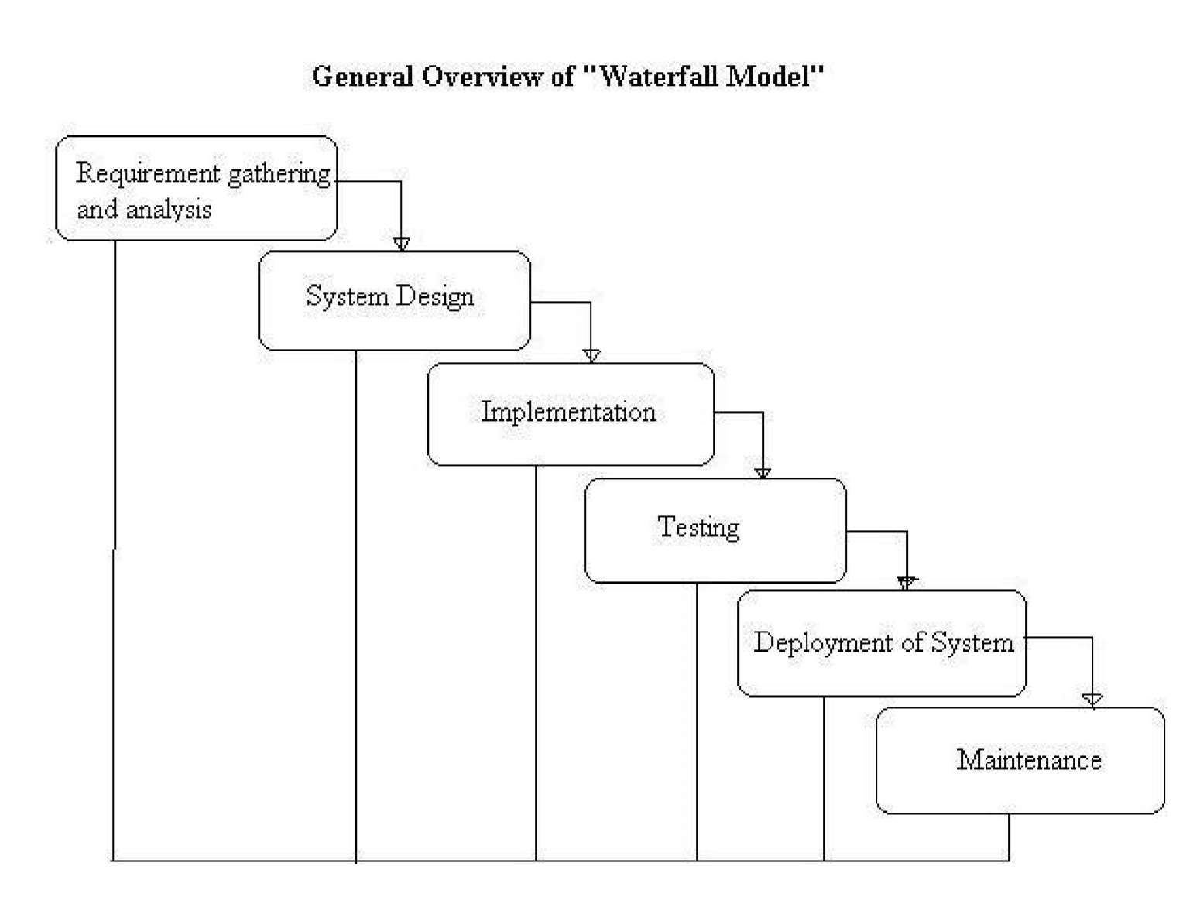

*We had pointed out in the previous section that in a practical software development project, the classical waterfall model is hard to use. We had branded the classical waterfall model as an idealistic model. In this context, the iterative waterfall model can be through of as incorporating the necessary changes to the classical waterfall model to make it usable in practical software development projects.*

*The feedback paths introduced by the iterative waterfall model are shown in above figure. The feedback paths allow the correcting errors committed by the programmers during some phase, as and when these are detected in a later phase. For example, if during the testing phase a design error is identified, then the feedback path allows the design to be reworked and the changes to be reflected on the design documents and all other subsequent documents.*

* + - ***Feasibility Study:*** *The main aim of the feasibility study activity is to deter mine weather it would be financially and technically feasible to develop the project.*

*All the technical feasibilities are used in our project* ***Online Shopping System****. The economical feasibilities are very low in our project* ***Online Shopping System.***

* + - ***Requirement analysis and specification:*** *The aim of requirement analysis and specification phase is to understand the exact requirement of the user and to document them properly. This project* ***Online Shopping System*** *is consists of two distinct activates, namely requirements gathering and analysis, and requirement specification.*

* + - ***Design:*** *The goal of our project* ***Online Shopping System*** *design phase is to transform the requirements specified from a user into a structure for implementation in the programming language that is used in this project.*

* + - ***Coding and Unit testing:*** *Coding means translate the software design into source code. When we start the unit testing of our project* ***Online Shopping System****, the functional modules have been tested separately so that, overall error could be reduced.*

* + - ***Integration and System testing:*** *When all the modules are coded and unity tested then we start the integration of our project* ***Online Shopping System****. We make a paper plan to integrate the different modules. After integrating those we got the finale software product.*

* + - ***Maintenance:*** *This is very importing in development of software. Here we can correct those errors those are not found in the development phase and also can improve the implement of the software and enhance the functions of our project*

***Online Shopping System****.*

* + **PROJECT DESCRIPTION:**

It is an efficient user friendly windows design for personal software assembles software.

It is an example of windows application using ***Visual Studio .net 2010 with SQL server 2008.***

There are two users-administrator and user.

The administrator has the full authority over the front end and back end of the software.

The user is provided only with an abstract view of selected interfaces.

The home page can be viewed by both the users. It contains various links to various interfaces. The administrator or the user can log in only through correct user name and password. Hence the system is password protected.

The administrator can insert the details of recently launched various types of product which when correctly entered get updated in the database.

The administrator also has the authority to insert, update or delete the details of particular products, if required which gets reflected to the database.

The administrator can insert new notice or rules as well as insert, update or delete previous announcements which again get reflected in database.

The administrator can change password which is then reflected in database.

Customer view details of the product and also can be request booking this product, can view Notice and Rules.

✪ **DATA FLOW DIAGRAM:**

**A** DFD is a graphic tool used to describe and analyzes the movement of the data through a system depicting the flow of data, store of data, source or destination of data and the processes that respond to changes in data. When the processes is described logically and independently of the physically components associated with the system. In contrast, physically data flow diagrams show the actual implementations and the movement of data between people, department and workstations.

The DFD is one of the most important tool sets by the system analyst to model system components namely

* System processes
* Any external entities that interact with the system (source or destination of the data) • Data store
* The information flows in the system

The following symbols are used is a Data flow diagram:

**Process:**

It is piece if work performed on data i.e. it shows what a system does.

**Data store:**

Data store is a place where data is held between processes, known as a file.

**External entities:**

Represent the people, programs organizations or other entities. Interact with the system by supply input or using outputs.

**Data flow:**

Shows the flow of data in the data flow diagram.

**Data Flow Diagram**

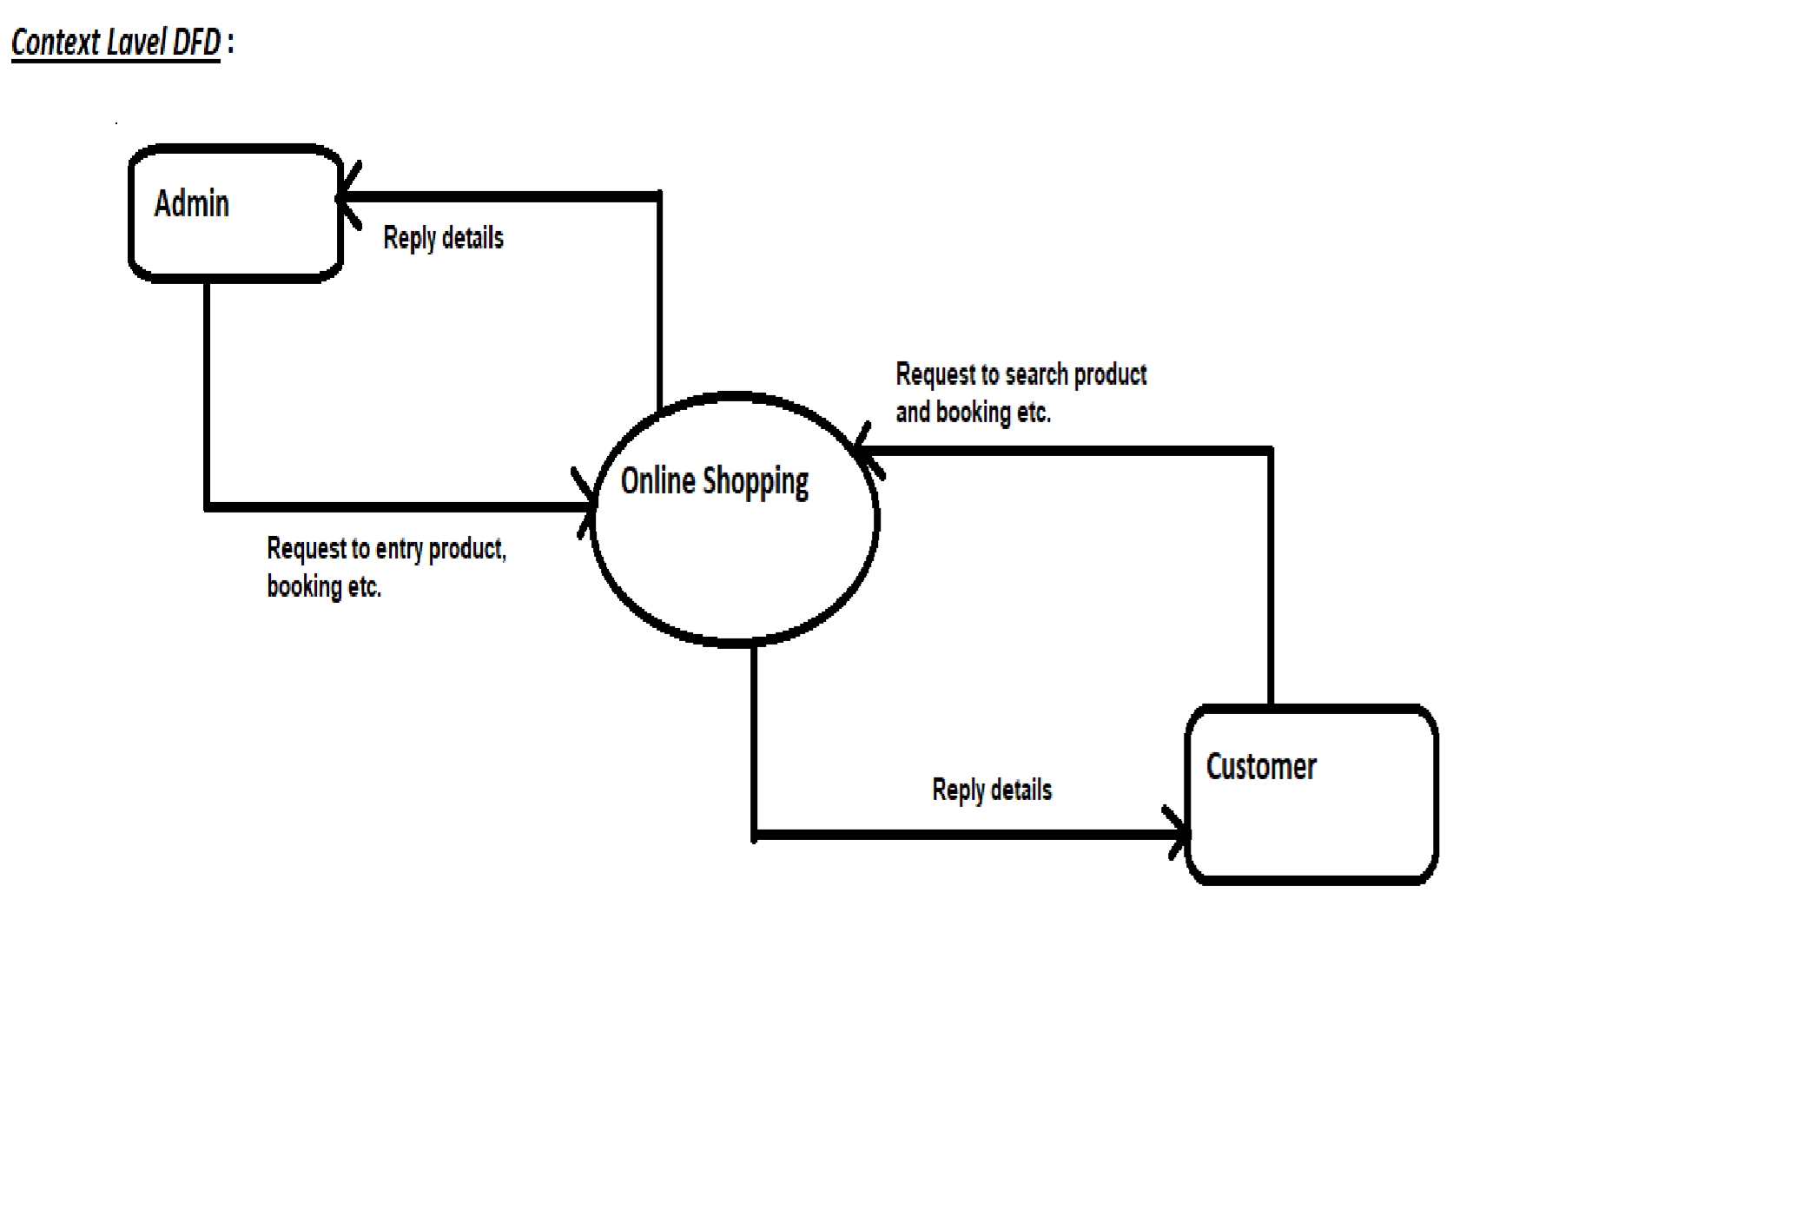

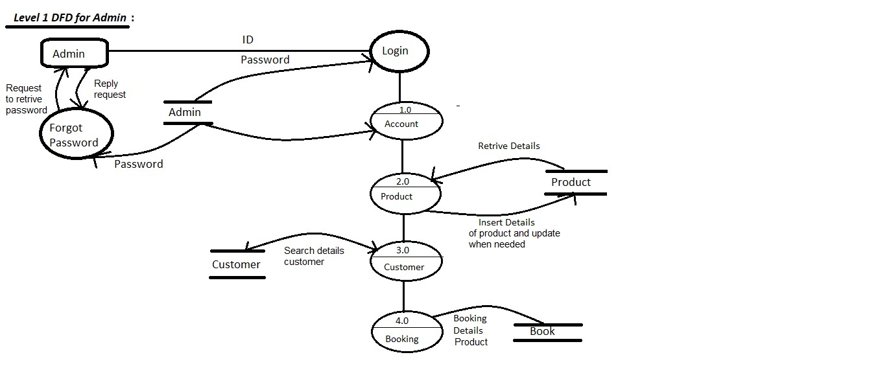

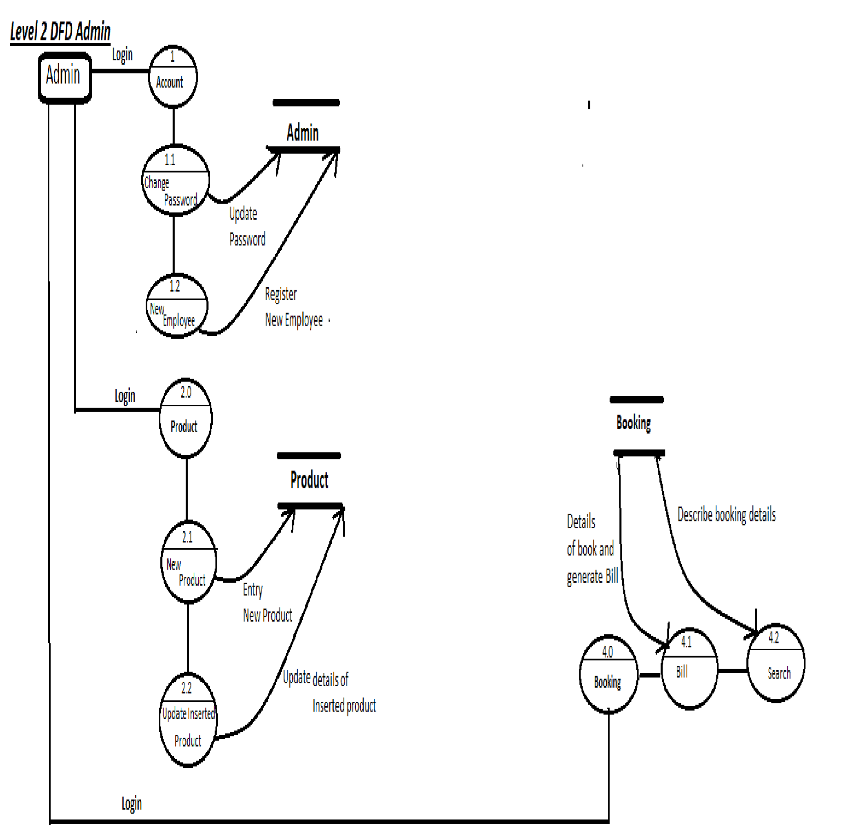

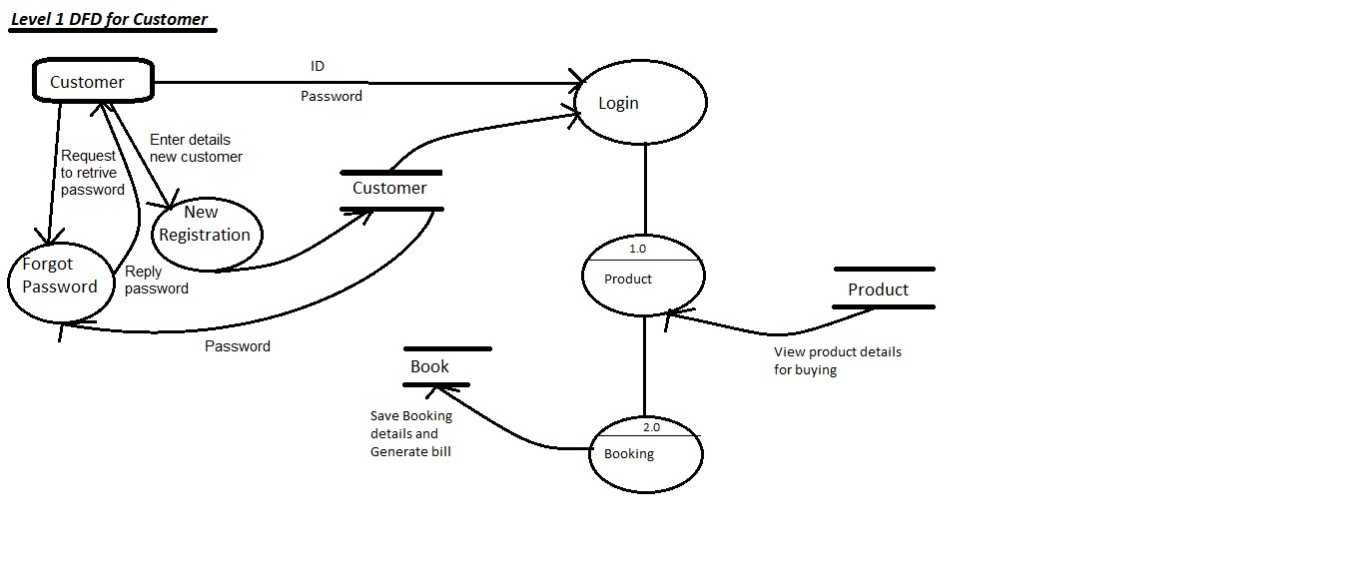

**Table:**

In our system we store the necessary information on such several user tables, which are as follows ……

1. **Admin**: used to hold admin record.
2. **Booking** :used to hold details booking information
3. **Cart** : Used to hold Items details for booking
4. **Customer**: Used to hold Customer Details
5. **Product:** Used to hold items details

✪ **DATABASE SCHEMA**

❖ **Tables used in our Project**

**Table: Admin**

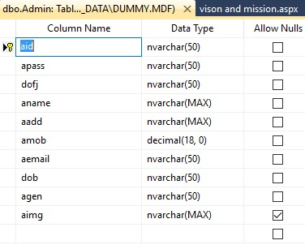

**Table: Booking**

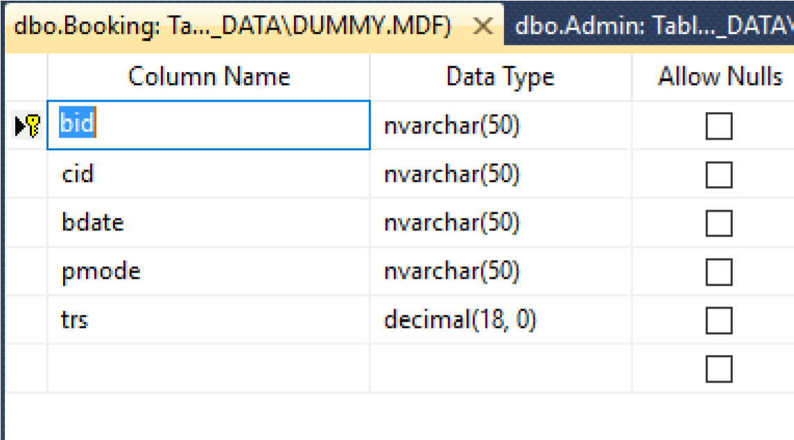

**Table: Cart**

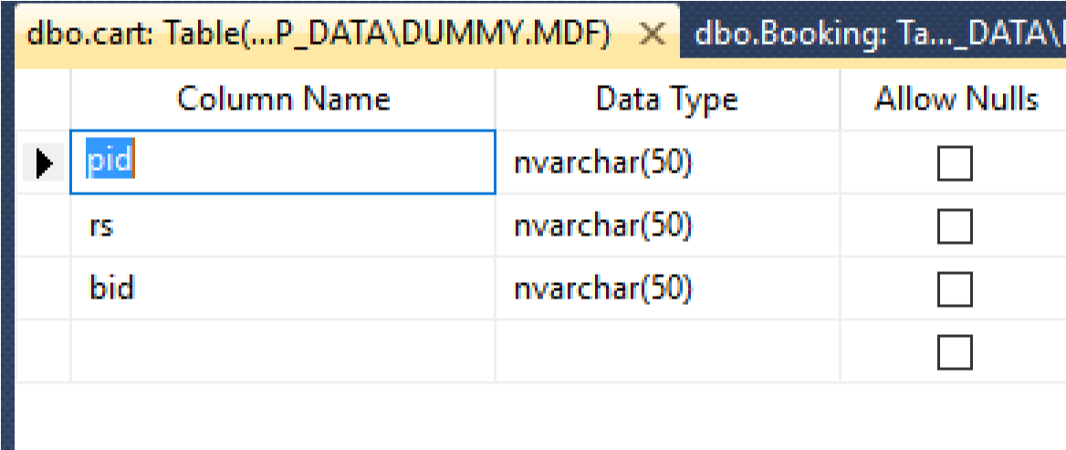

**Table: Customer**

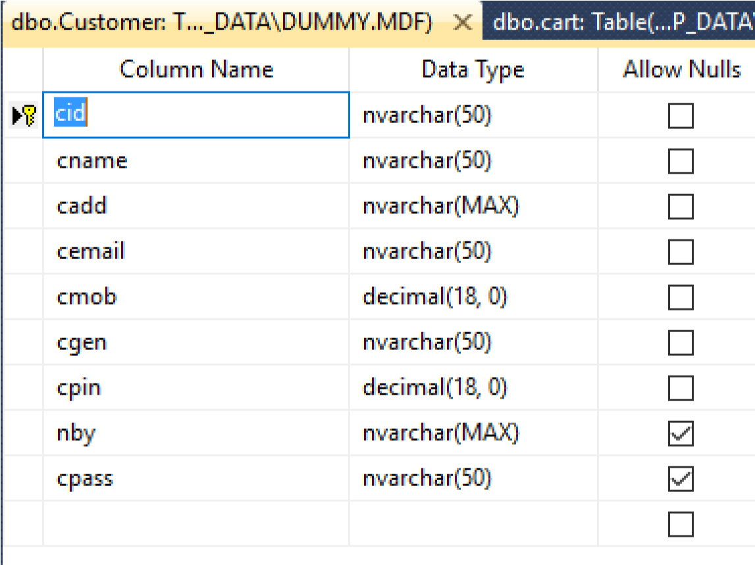

**Table: Product**

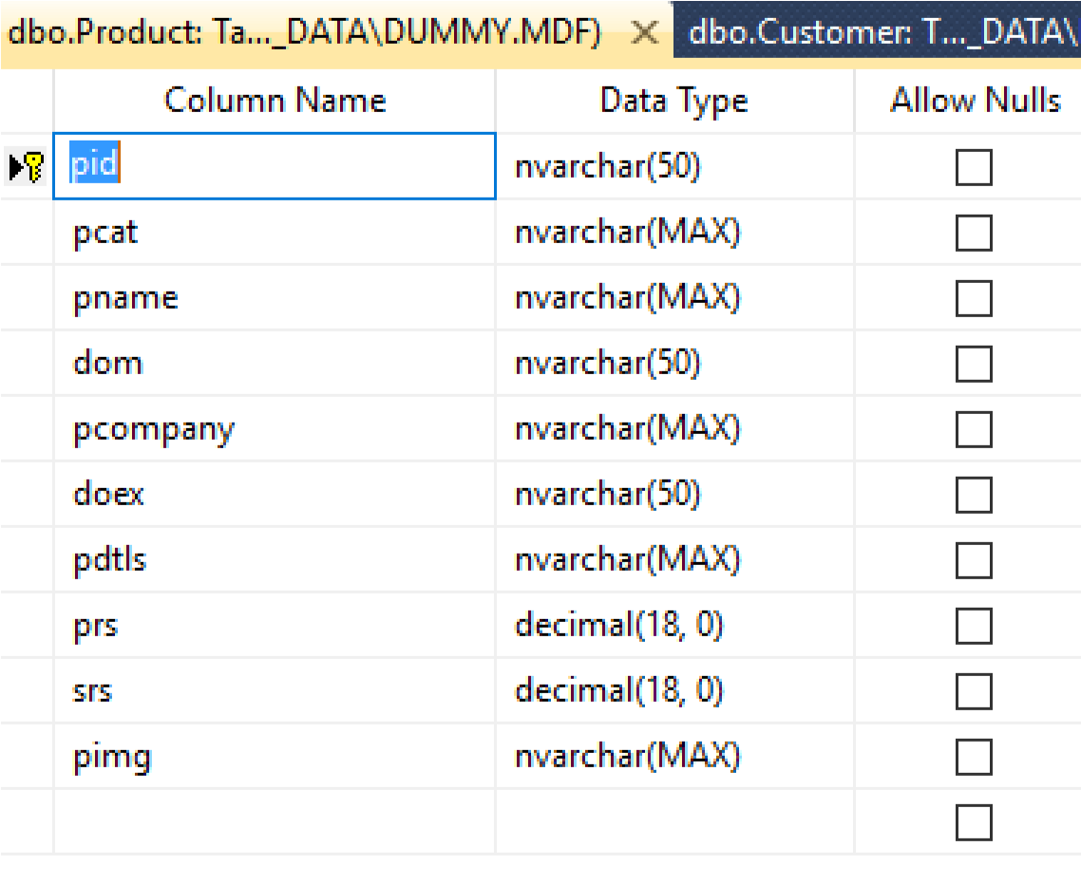

**ER Diagram**

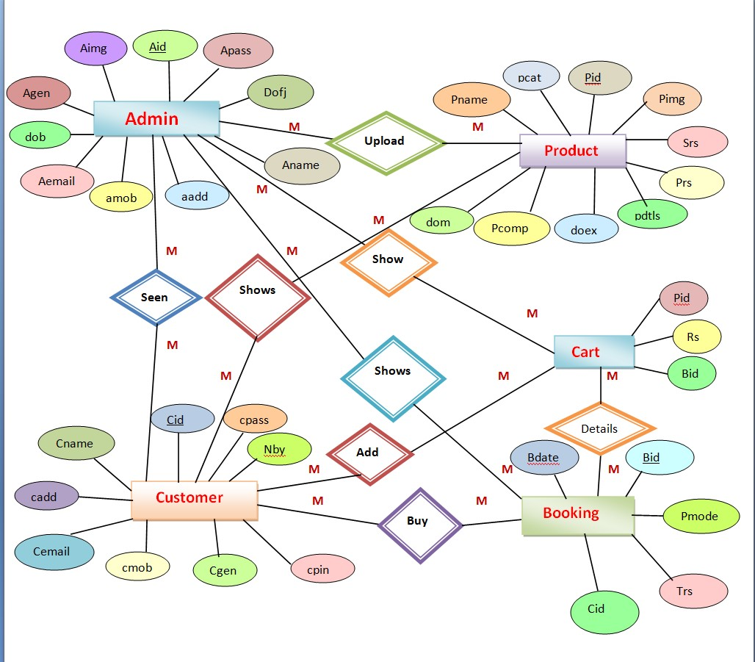

Use case diagram

***What is a Use Case Diagram?***

A use case diagram is a dynamic or behavior diagram in [UML.](https://www.smartdraw.com/uml-diagram/) Use case diagrams model the functionality of a system using actors and use cases. Use cases are a set of actions, services, and functions that the system needs to perform. In this context, a "system" is something being developed or operated, such as a web site.

The "actors" are people or entities operating under defined roles within the system.

***Why Make Use Case Diagrams?***

Use case diagrams are valuable for visualizing the functional requirements of a system that will translate into design choices and development priorities.

They also help identify any internal or external factors that may influence the system and should be taken into consideration.

They provide a good high level analysis from outside the system. Use case diagrams specify how the system interacts with actors without worrying about the details of how that functionality is implemented.

***Basic Use Case Diagram Symbols and Notations***

**System**

Draw your system's boundaries using a rectangle that contains use cases. Place actors outside the system's boundaries.

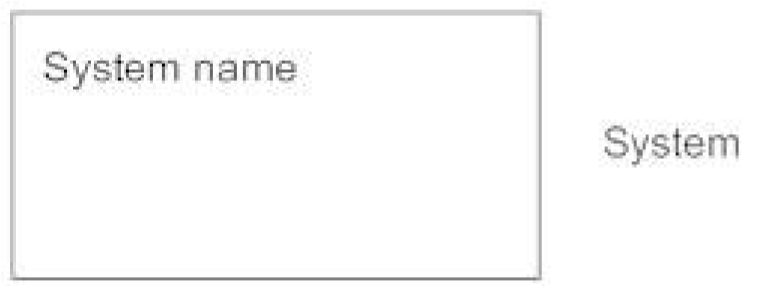

**Use Case**

Draw use cases using ovals. Label the ovals with verbs that represent the system's functions.

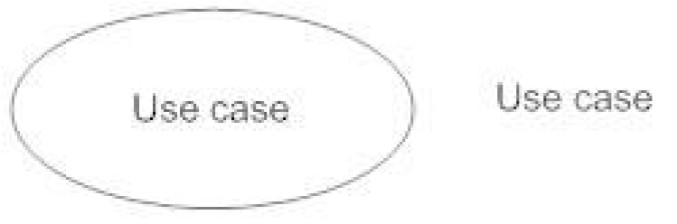

**Actors**

Actors are the users of a system. When one system is the actor of another system, label the actor system with the actor stereotype.

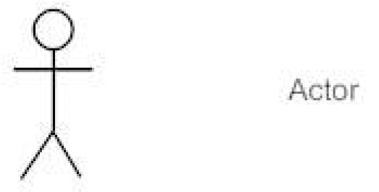

**Relationships**

Illustrate relationships between an actor and a use case with a simple line. For relationships among use cases, use arrows labeled either "uses" or "extends." A "uses" relationship indicates that one use case is needed by another in order to perform a task. An "extends" relationship indicates alternative options under a certain use case.

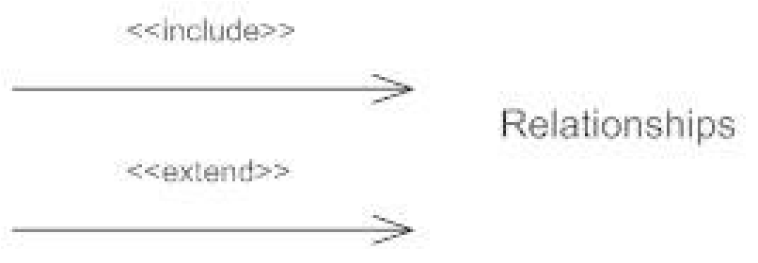

**Use Case Diagram**

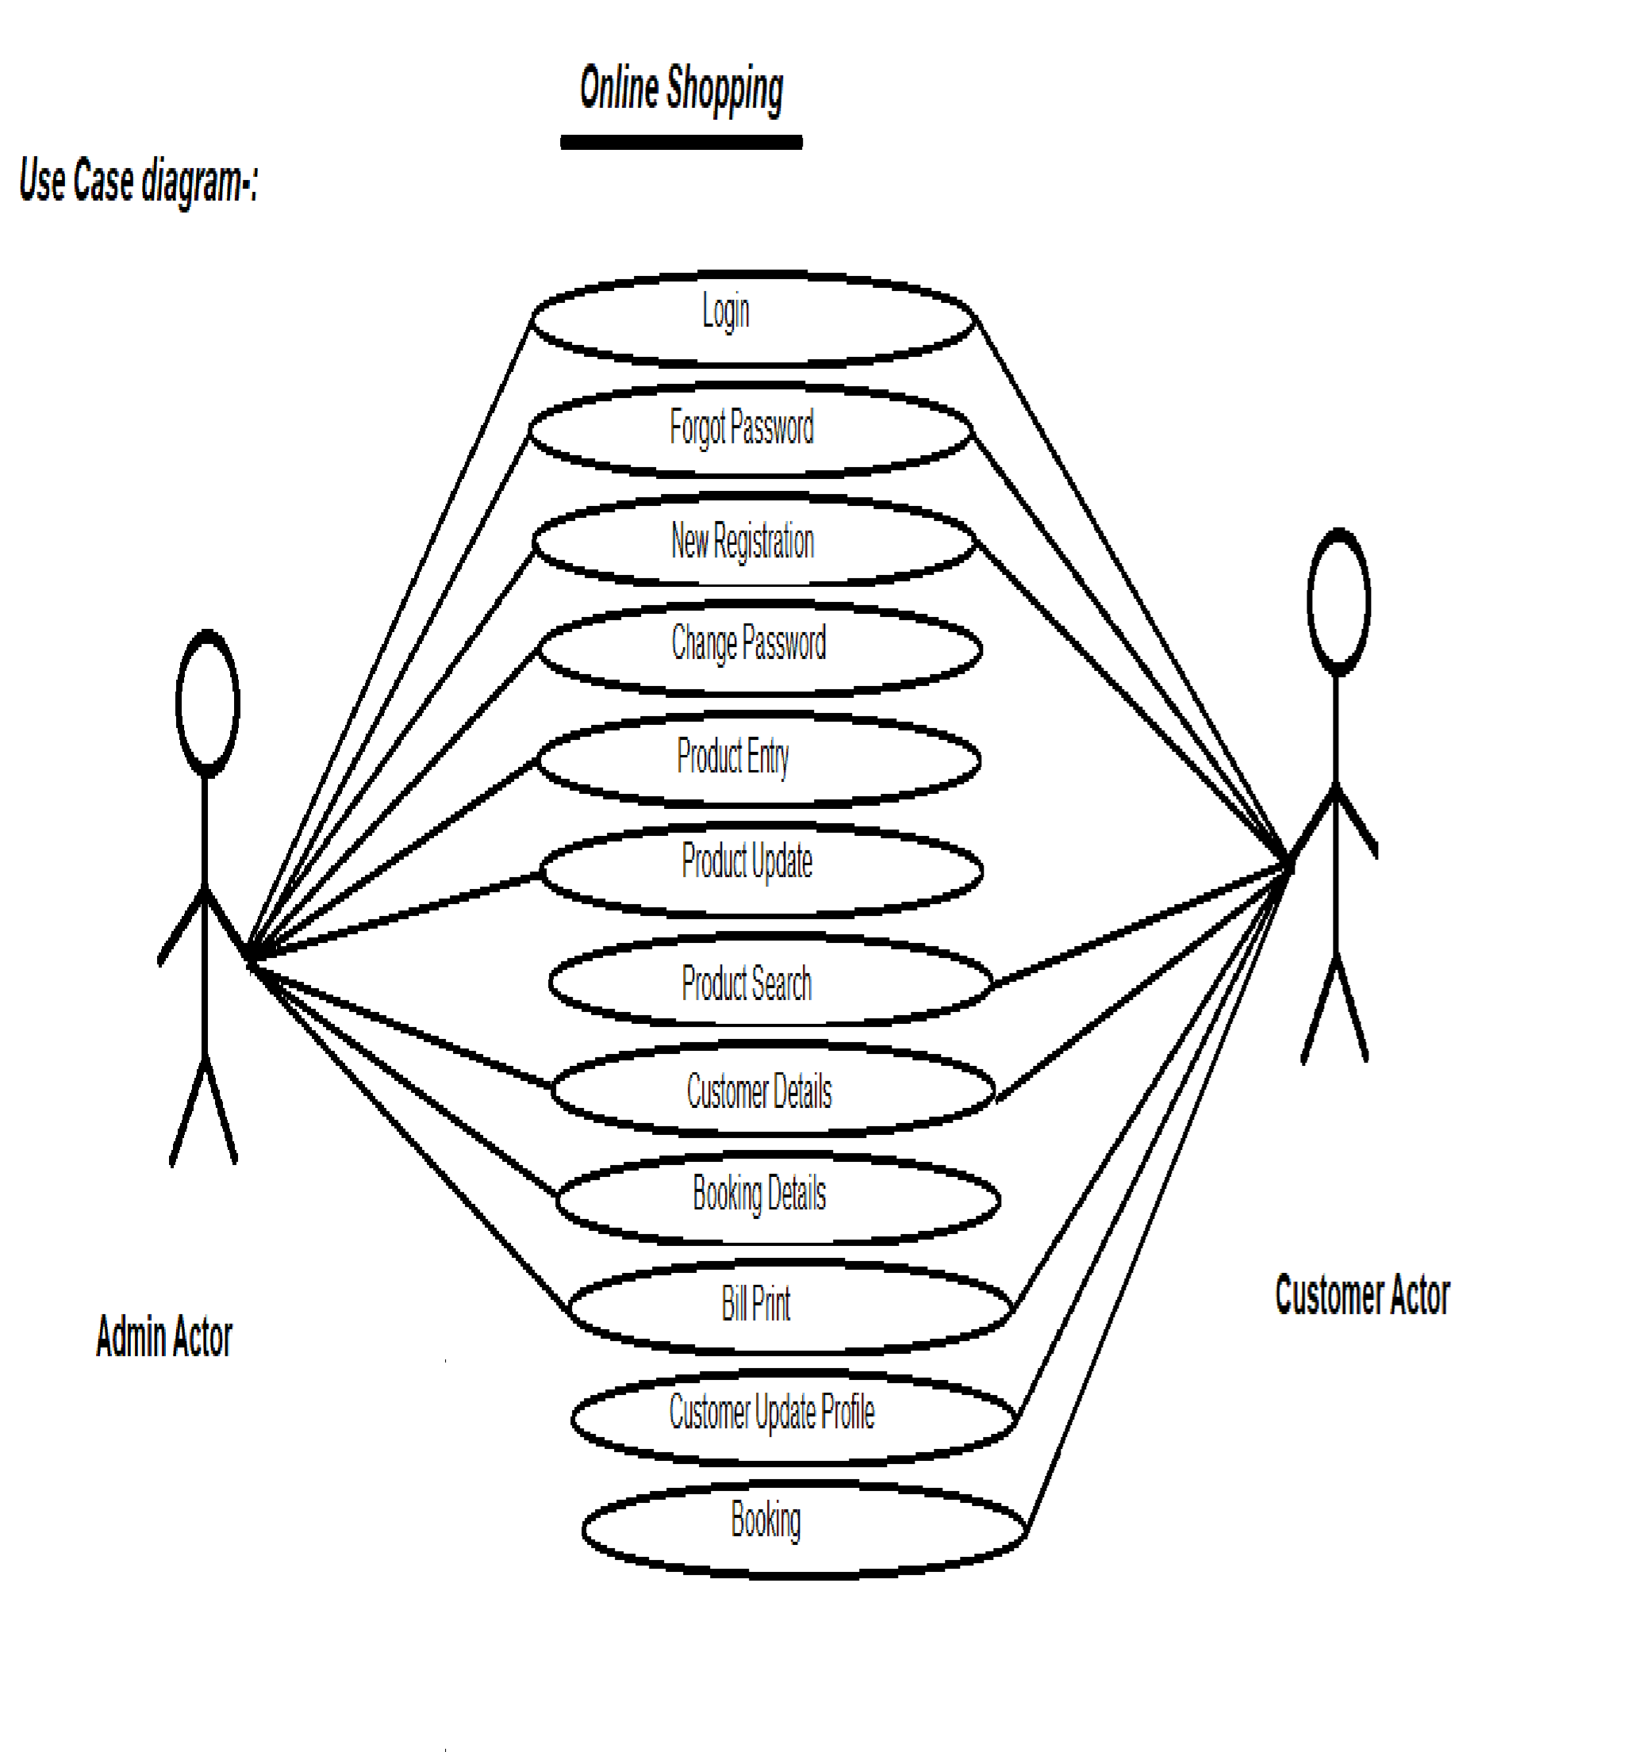

**Figure: Online Shopping System**

**PROJECT LAYOUT AND PROJECT CODE:**

❖ **A Sample Form For The Admin Login Manual:**

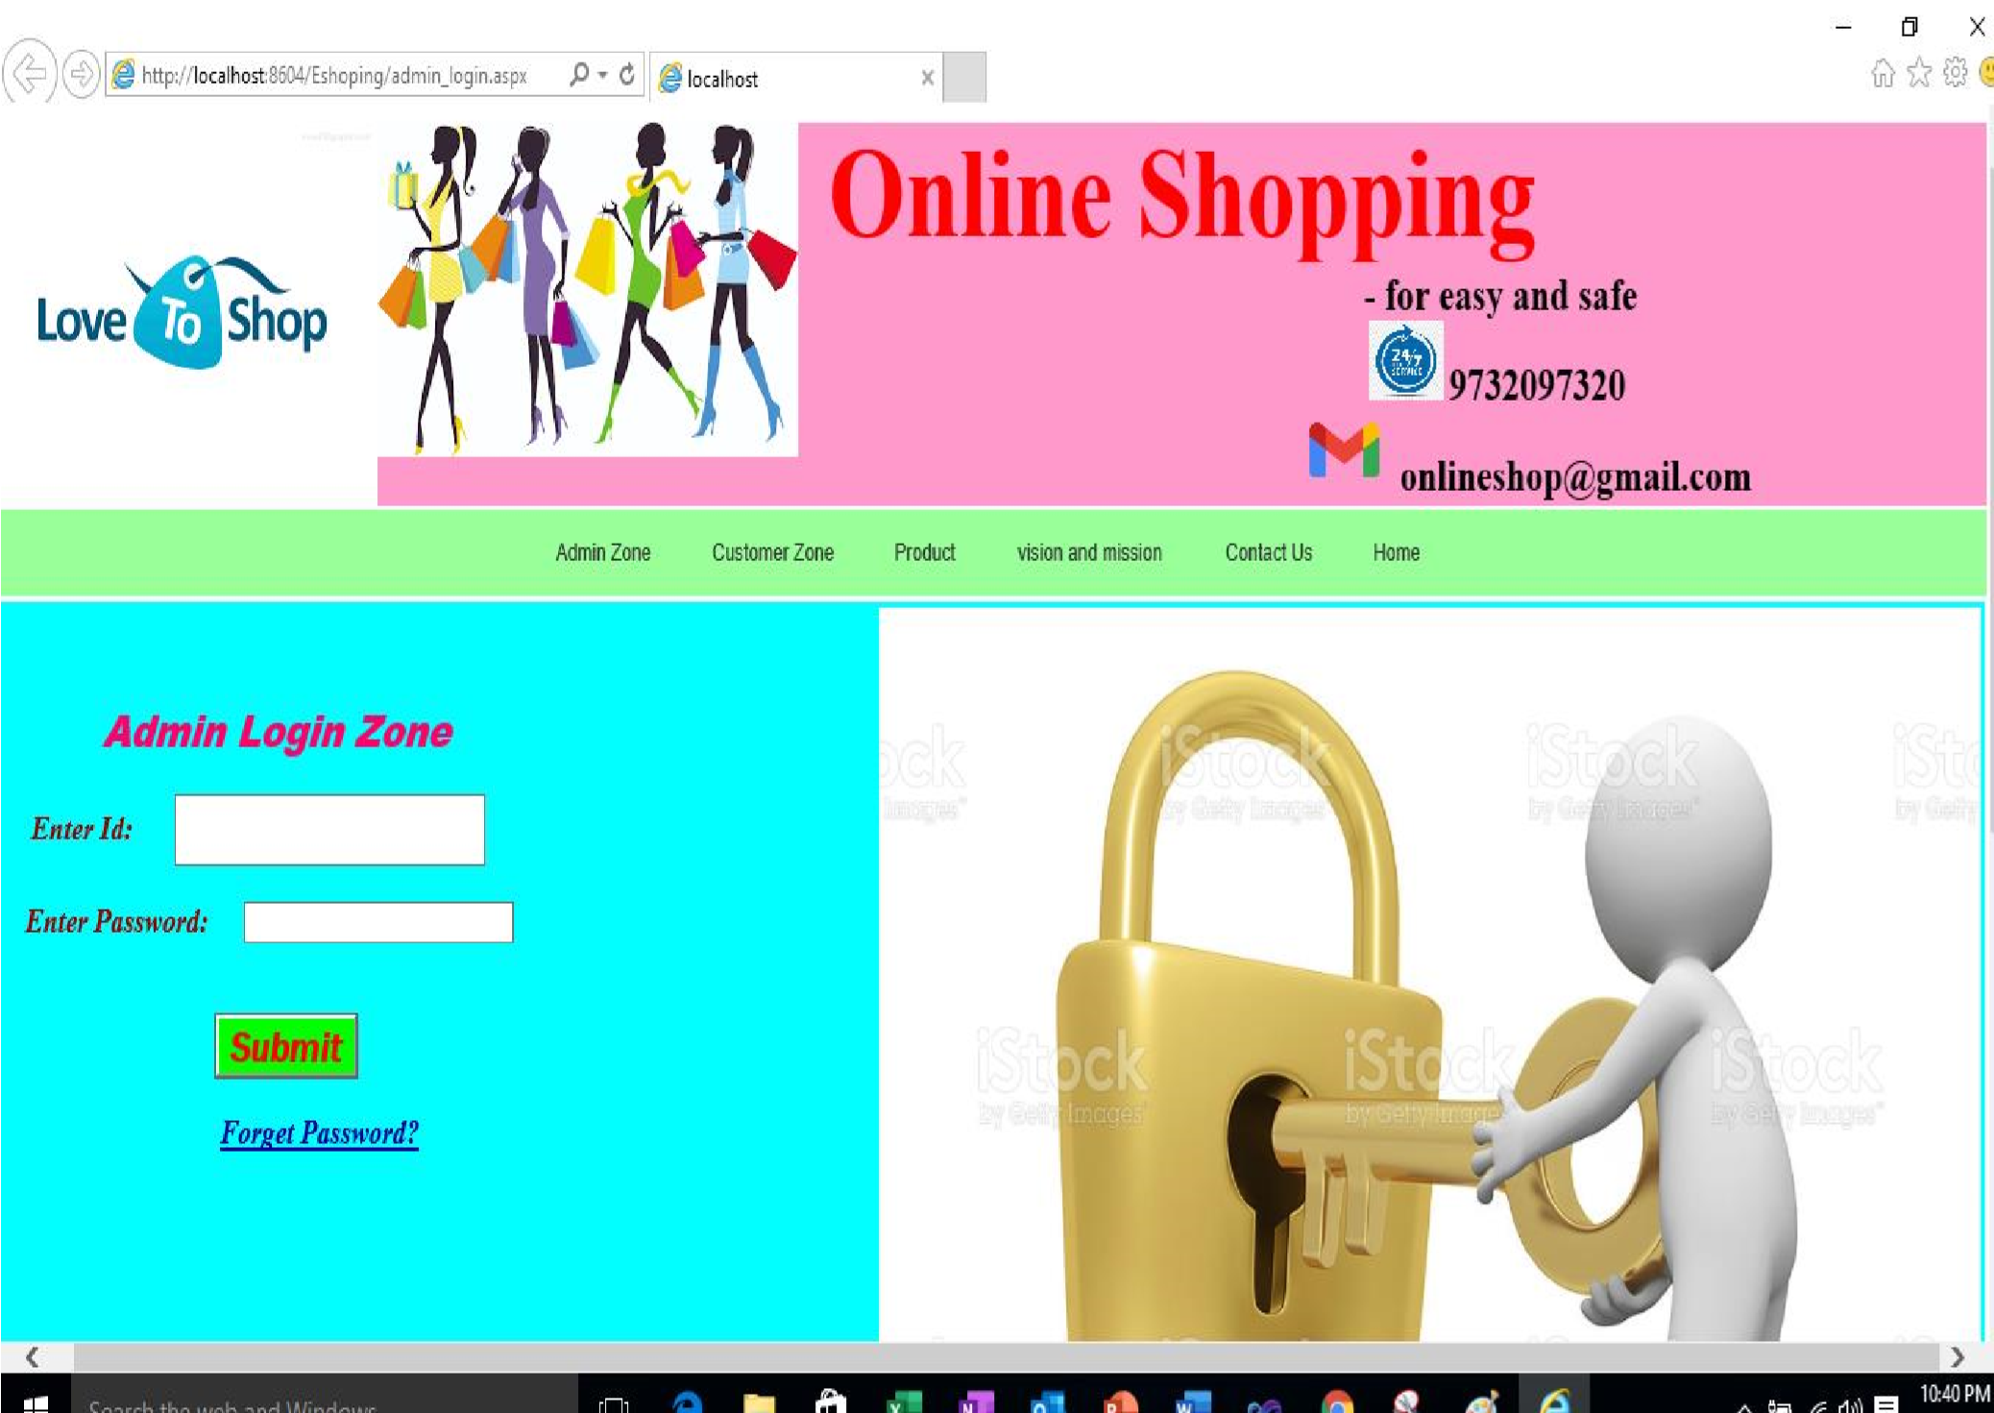

❖

**A Sample .Net Coding For The Above Form**

Imports System.Data

Imports System.Data.SqlClient

Partial Class admin_login

Inherits System.Web.UI.Page

Dim cmd As SqlCommand

Dim con As New SqlConnection("Data

Source=.\SQLEXPRESS;AttachDbFilename=|DataDirectory|\Dummy.mdf;Integrated Security=True;User

Instance=True")

Protected Sub Button1_Click(ByVal sender As Object, ByVal e As System.EventArgs) Handles Button1.Click Try con.Open()

cmd = New SqlCommand("select * from Admin where aid='" + TextBox1.Text + "' and apass='" + TextBox3.Text + "'", con)

Dim dr As SqlDataReader

dr = cmd.ExecuteReader

If dr.Read Then

Session("aid") = TextBox1.Text

Response.Redirect("After_login_home.aspx")

Else

MsgBox("enter wrong password", MsgBoxStyle.YesNo)

End If

Catch ex As Exception End Try con.Close()

End Sub

End Class

❖ **A Sample Form For The Admin Change password Manual:**

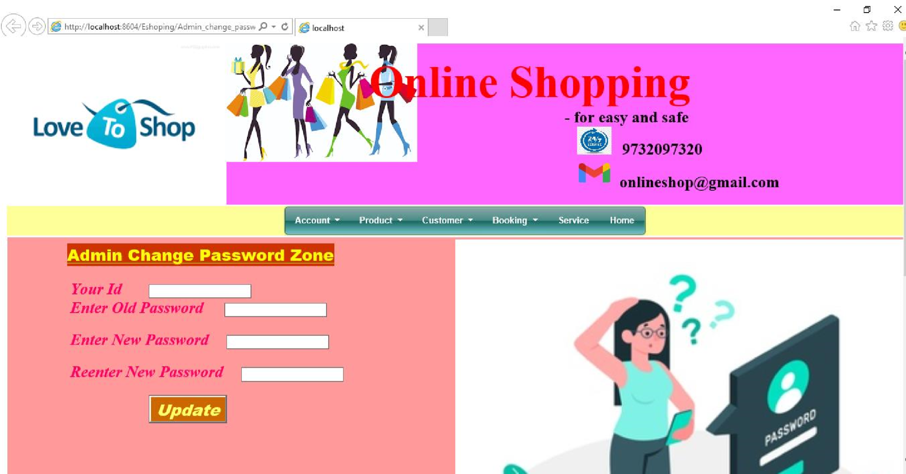

❖

**A Sample .Net Coding For The Above Form**

Imports System.Data

Imports System.Data.SqlClient

Imports System.Configuration

Imports System.IO

Partial Class Admin_change_password Inherits System.Web.UI.Page

Dim cmd, cmd1 As New SqlCommand

Dim dr, dr2 As SqlDataReader

Dim con As New SqlConnection("Data

Source=.\SQLEXPRESS;AttachDbFilename=|DataDirectory|\Dummy.mdf;Integrated Security=True;User

Instance=True")

Protected Sub Button1_Click(ByVal sender As Object, ByVal e As System.EventArgs) Handles Button1.Click con.Open()

Try

If TextBox3.Text <> TextBox2.Text Then

MsgBox("You have enter worong old password", MsgBoxStyle.OkCancel) Else

cmd1 = New SqlCommand("update Admin set apass='" + TextBox5.Text + "' where aid='"

+ TextBox1.Text + "'", con)

cmd1.ExecuteReader()

Label6.Text = "Your Password Update Successfully"

End If

Catch ex As Exception

End Try

con.Close()

End Sub

Protected Sub Page_Load(ByVal sender As Object, ByVal e As System.EventArgs) Handles Me.Load

TextBox1.Text = Session("aid")

con.Open() Try

cmd = New SqlCommand("select * from Admin where aid='" + TextBox1.Text + "' ", con) dr = cmd.ExecuteReader

If dr.Read Then

TextBox3.Text = dr(1).ToString

End If

Catch ex As Exception

MsgBox(ex.Message) End Try con.Close()

End Sub

End Class

❖ **A Sample Form For The forgot password Manual:**

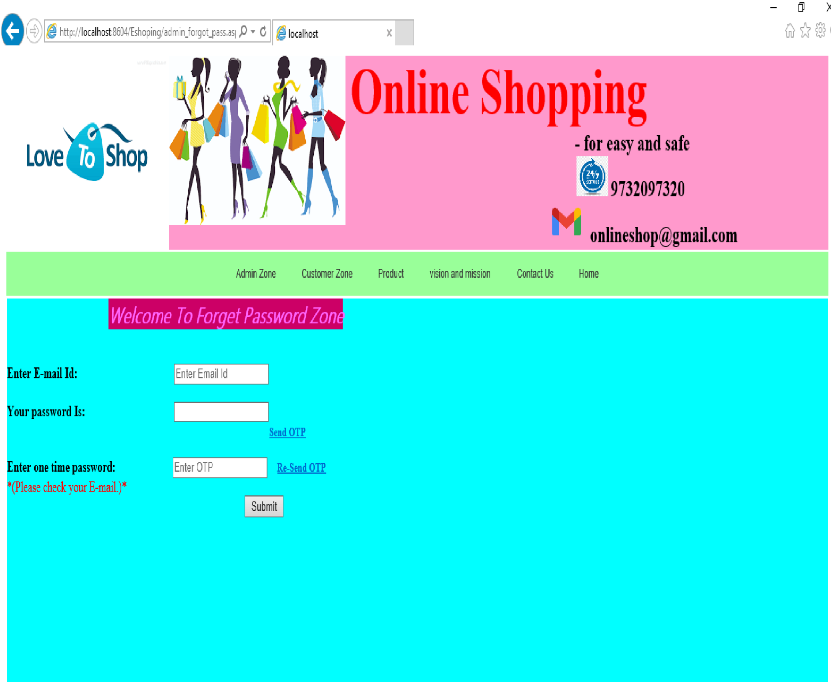

❖ 

**A Sample .Net Coding For The Above Form**

Imports System.Data

Imports System.Data.SqlClient

Imports System.Configuration

Imports System.IO

Imports System.Net.Mail

Imports System.Net

Partial Class admin_forgot_pass

Inherits System.Web.UI.Page

Dim cmd, cmd2 As New SqlCommand

Dim dr, dr2 As SqlDataReader

Dim con As New SqlConnection("Data

Source=.\SQLEXPRESS;AttachDbFilename=|DataDirectory|\Dummy.mdf;Integrated Security=True;User

Instance=True")

Protected Sub LinkButton1_Click(ByVal sender As Object, ByVal e As System.EventArgs) Handles LinkButton1.Click

Dim rand1 As New Random()

Dim p As Integer

For p = 1 To 100

Label7.Text = rand1.Next(3000)

TextBox4.Text = Val(Label7.Text)

Next

Dim fromAdress As String = TextBox7.Text

Dim fromPassword As String = TextBox8.Text

Dim mailSubject As String = TextBox10.Text

Dim mailBody As String = TextBox4.Text

Dim toAddress As String = TextBox1.Text

Dim smtp As New SmtpClient("smtp.gmail.com", 587) smtp.EnableSsl = True

smtp.UseDefaultCredentials = False

smtp.Credentials = New NetworkCredential(fromAdress, fromPassword) Dim mail As New MailMessage(fromAdress, toAddress, mailSubject, mailBody) Try

smtp.Send(mail) Catch ex As Exception

Label16.Text = ex.Message.ToString End Try con.Close()

End Sub

Protected Sub LinkButton2_Click(ByVal sender As Object, ByVal e As System.EventArgs) Handles LinkButton2.Click

Dim rand1 As New Random()

Dim p As Integer

For p = 1 To 100

Label7.Text = rand1.Next(3000)

TextBox4.Text = Val(Label7.Text)

Next

Dim fromAdress As String = TextBox7.Text

Dim fromPassword As String = TextBox8.Text

Dim mailSubject As String = TextBox10.Text Dim mailBody As String = TextBox4.Text

Dim toAddress As String = TextBox1.Text

Dim smtp As New SmtpClient("smtp.gmail.com", 587) smtp.EnableSsl = True

smtp.UseDefaultCredentials = False

smtp.Credentials = New NetworkCredential(fromAdress, fromPassword) Dim mail As New MailMessage(fromAdress, toAddress, mailSubject, mailBody) Try

smtp.Send(mail) Catch ex As Exception

Label16.Text = ex.Message.ToString End Try con.Close()

End Sub

Protected Sub Button1_Click(ByVal sender As Object, ByVal e As System.EventArgs) Handles Button1.Click con.Open()

Try

If Val(Label7.Text) = Val(TextBox3.Text) Then

cmd = New SqlCommand("select * from Admin where aemail='" + TextBox1.Text + "'", con)

dr = cmd.ExecuteReader

If dr.Read Then

TextBox9.Text = dr(1).ToString

End If

Else

MsgBox("you are wrong user", MsgBoxStyle.Information) End If

Catch ex As Exception

MsgBox(ex.Message) Finally con.Close()

cmd.Dispose()

End Try

End Sub

End Class

❖ **A Sample Form For The Admin New Registration Manual:**

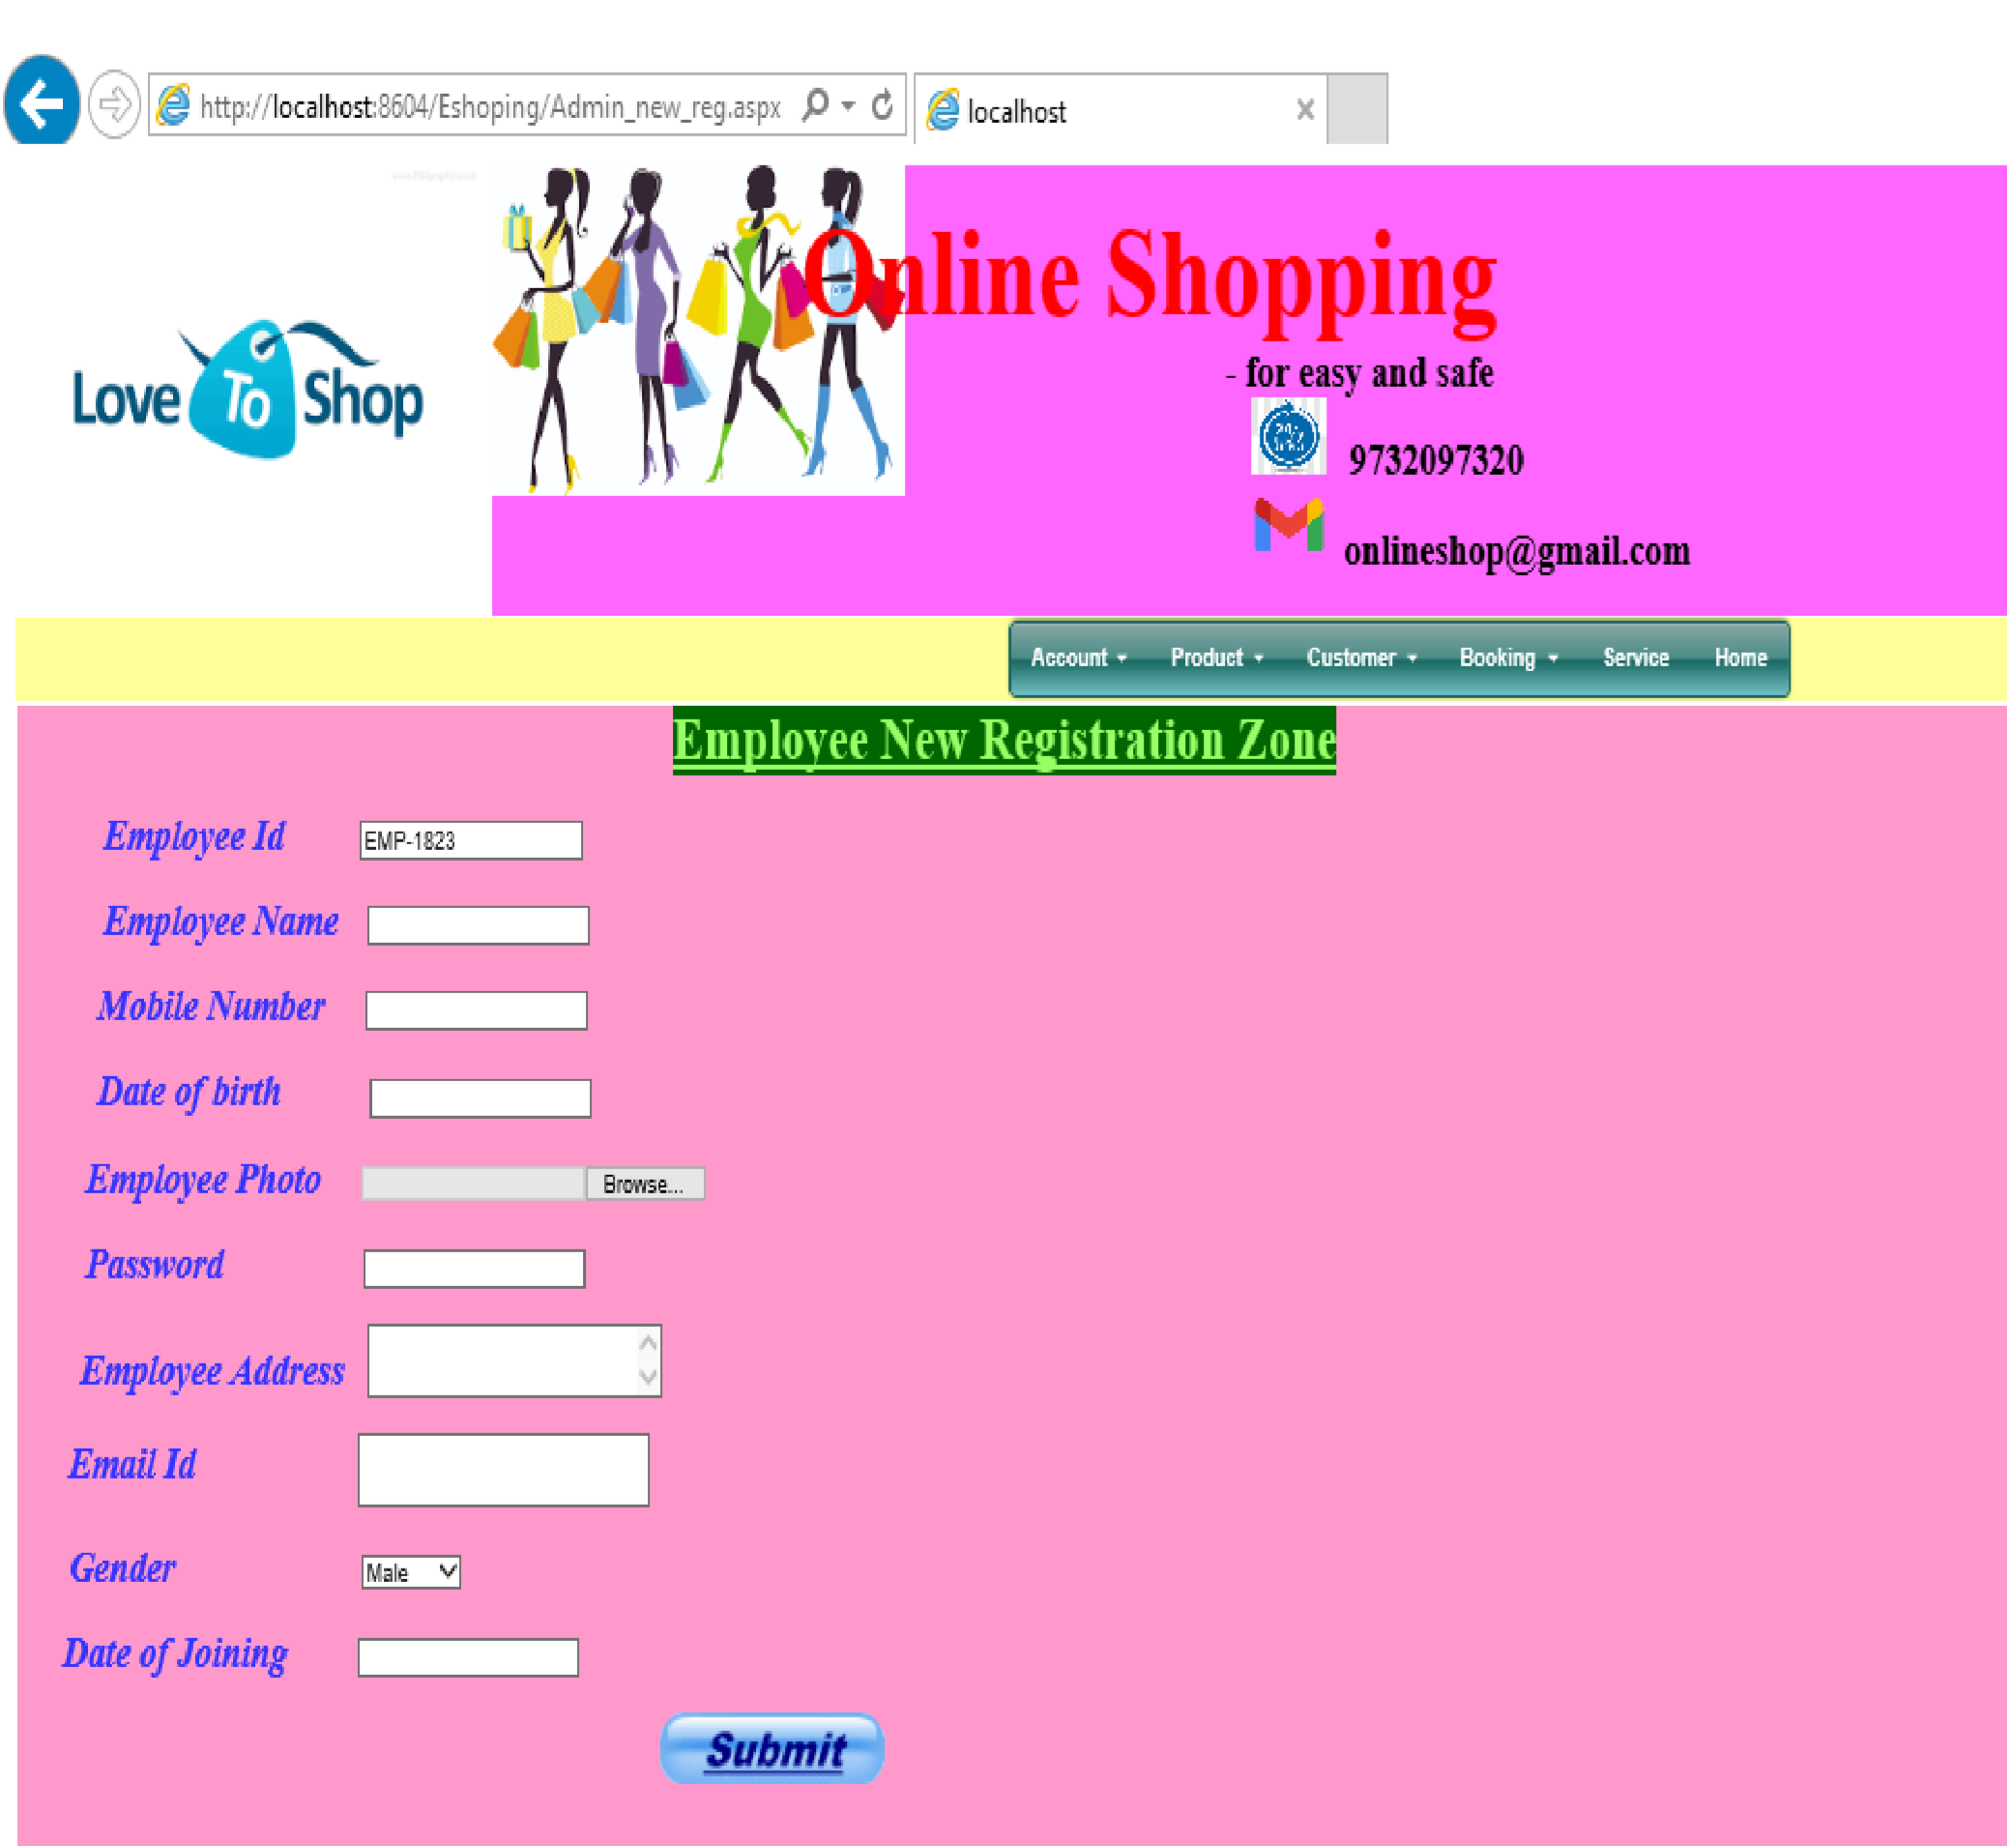

❖

**A Sample .Net Coding For The Above Form**

Imports System.Data

Imports System.Data.SqlClient

Imports System.Configuration

Imports System.IO

Partial Class Admin_new_reg

Inherits System.Web.UI.Page

Dim fileName As String = String.Empty

Dim filePath As String = String.Empty

Dim cmd1, cmd2 As New SqlCommand

Dim dr1, dr2 As SqlDataReader

Dim con As New SqlConnection("Data

Source=.\SQLEXPRESS;AttachDbFilename=|DataDirectory|\Dummy.mdf;Integrated Security=True;User

Instance=True")

Protected Sub ImageButton1_Click(ByVal sender As Object, ByVal e As

System.Web.UI.ImageClickEventArgs) Handles ImageButton1.Click con.Open()

Try

If FileUpload1.HasFile Then fileName = FileUpload1.FileName

filePath = Server.MapPath("~/emp/" & Convert.ToString(fileName)) FileUpload1.SaveAs(filePath) fileName = "~/emp/" & fileName End If

cmd2 = New SqlCommand("insert into

Admin(aid,apass,dofj,aname,aadd,amob,aemail,dob,agen,aimg)

values(@aid,@apass,@dofj,@aname,@aadd,@amob,@aemail,@dob,@agen,@aimg)", con) cmd2.Parameters.AddWithValue("@aid", TextBox1.Text.Trim()) cmd2.Parameters.AddWithValue("@apass", TextBox5.Text.Trim()) cmd2.Parameters.AddWithValue("@dofj", TextBox8.Text.Trim()) cmd2.Parameters.AddWithValue("@aname", TextBox2.Text.Trim()) cmd2.Parameters.AddWithValue("@aadd", TextBox6.Text.Trim()) cmd2.Parameters.AddWithValue("@amob", TextBox3.Text.Trim()) cmd2.Parameters.AddWithValue("@aemail", TextBox7.Text.Trim()) cmd2.Parameters.AddWithValue("@dob", TextBox4.Text.Trim())

cmd2.Parameters.AddWithValue("@agen", DropDownList1.SelectedItem.Text.Trim()) cmd2.Parameters.AddWithValue("@aimg", fileName) cmd2.ExecuteReader()

Label16.Text = "Registration is Successful"

Catch ex As Exception

MsgBox(ex.Message) Finally con.Close() cmd2.Dispose() fileName = Nothing filePath = Nothing TextBox5.Text = ""

TextBox2.Text = ""

TextBox3.Text = ""

TextBox4.Text = ""

TextBox6.Text = ""

TextBox7.Text = ""

TextBox8.Text = ""

con.Close()

End Try

End Sub

Protected Sub Page_Load(ByVal sender As Object, ByVal e As System.EventArgs) Handles Me.Load Dim rand1 As New Random()

Dim p As Integer

For p = 1 To 100

TextBox1.Text = "EMP-" & rand1.Next(3000)

Next

End Sub

End Class

❖ **A Sample Form For The Customer Login Manual:**

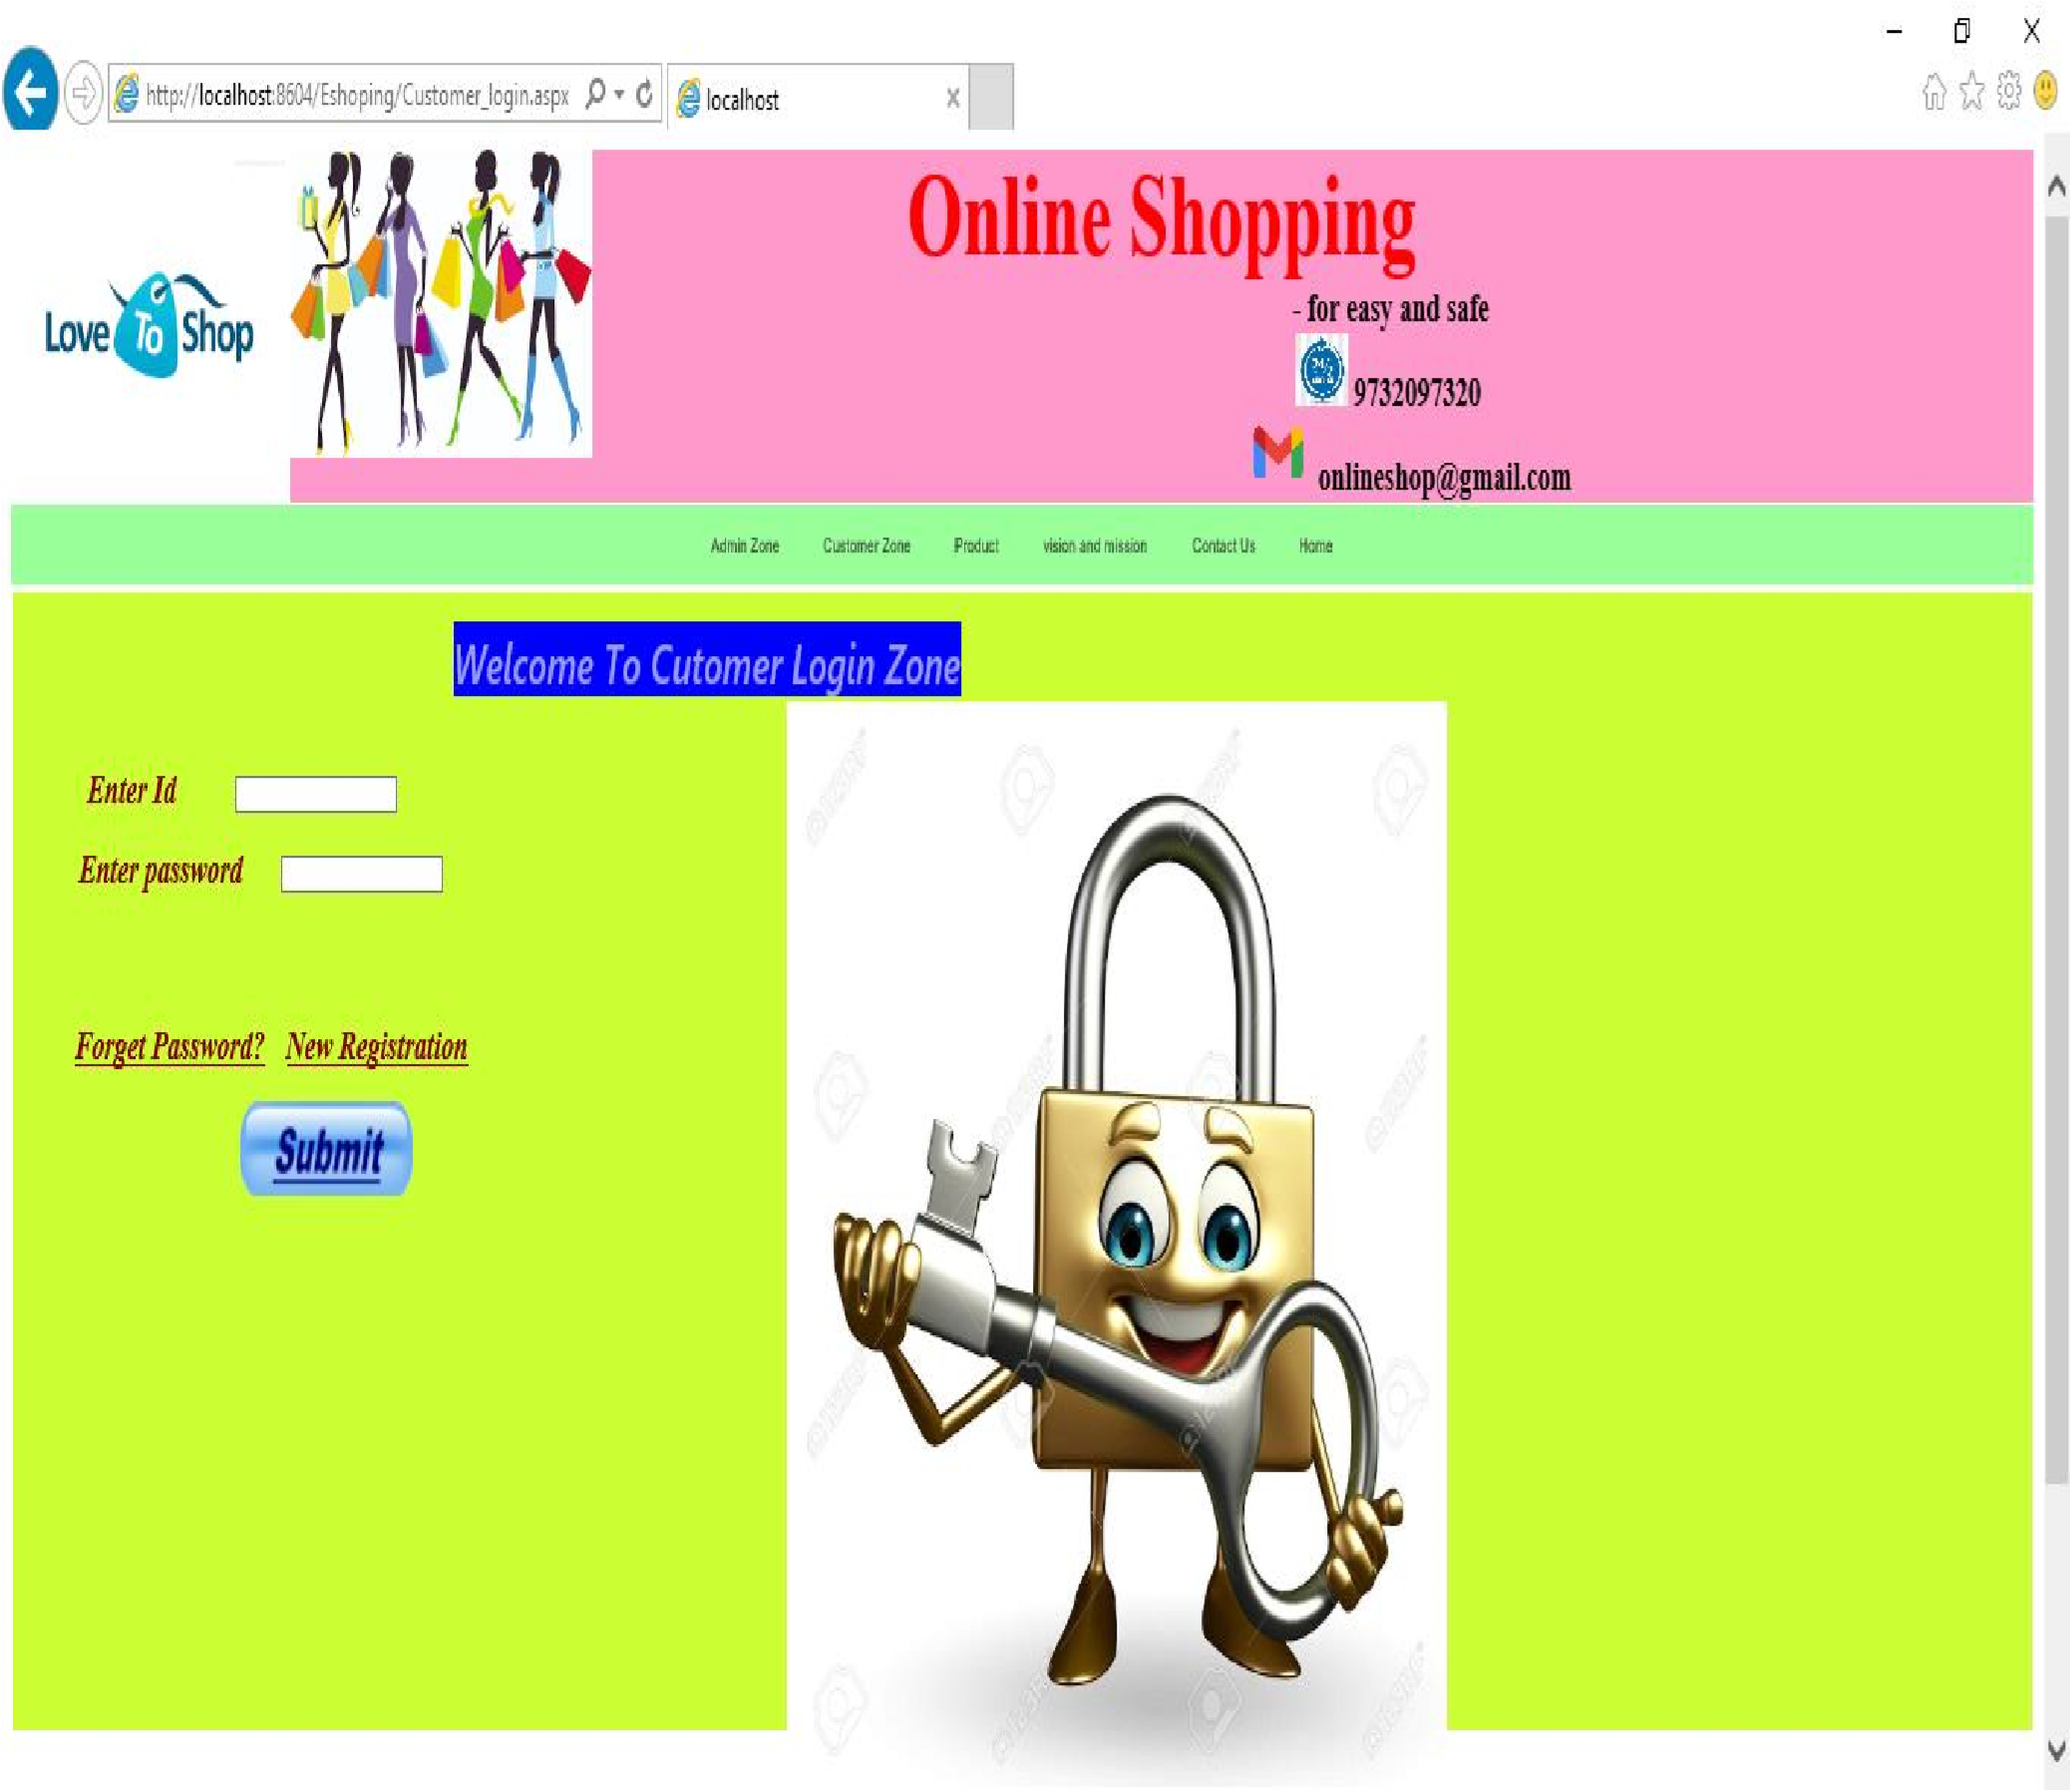

Imports System.Data

Imports System.Data.SqlClient

Partial Class Customer_login

Inherits System.Web.UI.Page

Dim cmd As SqlCommand

Dim con As New SqlConnection("Data

Source=.\SQLEXPRESS;AttachDbFilename=|DataDirectory|\Dummy.mdf;Integrated Security=True;User

❖

**A Sample .Net Coding For The Above Form**

Instance=True")

Protected Sub ImageButton1_Click(ByVal sender As Object, ByVal e As

System.Web.UI.ImageClickEventArgs) Handles ImageButton1.Click Try con.Open()

cmd = New SqlCommand("select * from Customer where cid='" + TextBox1.Text + "' and cpass='" + TextBox2.Text + "'", con)

Dim dr As SqlDataReader

dr = cmd.ExecuteReader

If dr.Read Then

Session("cid") = TextBox1.Text

Response.Redirect("Customer_product_search.aspx") Else

MsgBox("You enter wrong password", MsgBoxStyle.YesNo)

End If

Catch ex As Exception End Try con.Close()

End Sub

End Class

❖ **A Sample Form For The Customer New Registration Manual:**

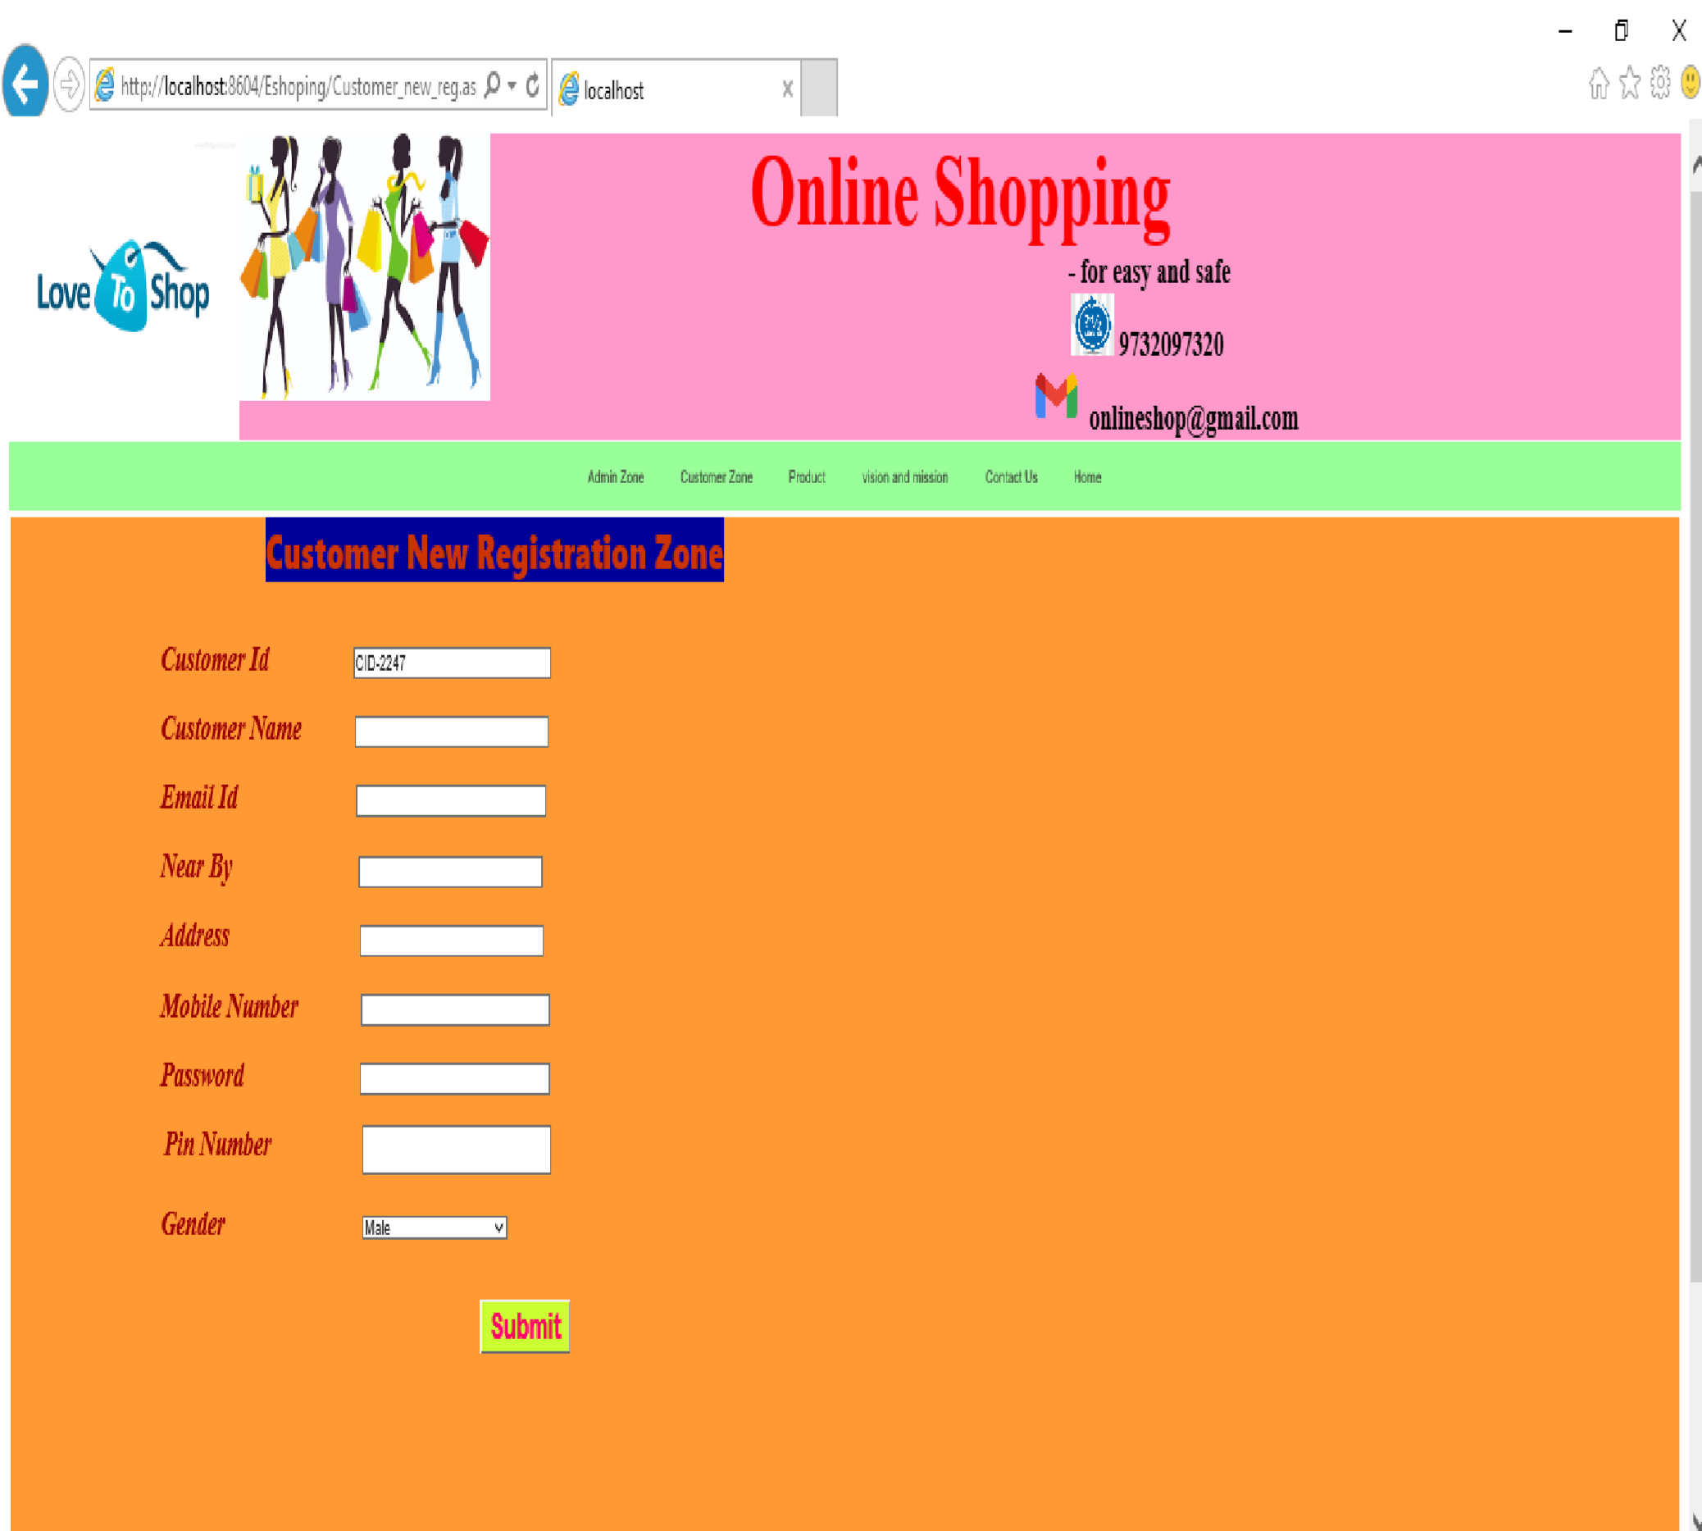

❖

**A Sample .Net Coding For The**

**Above Form**

Imports System.Data

Imports System.Data.SqlClient

Imports System.Configuration

Imports System.IO

Partial Class Customer_new_reg

Inherits System.Web.UI.Page

Dim cmd1, cmd2 As New SqlCommand

Dim dr1, dr2 As SqlDataReader

Dim con As New SqlConnection("Data

Source=.\SQLEXPRESS;AttachDbFilename=|DataDirectory|\Dummy.mdf;Integrated Security=True;User

Instance=True")

Protected Sub Page_Load(ByVal sender As Object, ByVal e As System.EventArgs) Handles Me.Load Dim rand1 As New Random()

Dim p As Integer

For p = 1 To 100

TextBox1.Text = "CID-" & rand1.Next(3000)

Next

End Sub

Protected Sub Button1_Click(ByVal sender As Object, ByVal e As System.EventArgs) Handles Button1.Click con.Open()

Try

cmd2 = New SqlCommand("insert into

Customer(cid,cname,cadd,cemail,cmob,cgen,cpin,nby,cpass)

values(@cid,@cname,@cadd,@cemail,@cmob,@cgen,@cpin,@nby,@cpass)", con) cmd2.Parameters.AddWithValue("@cid", TextBox1.Text.Trim()) cmd2.Parameters.AddWithValue("@cname", TextBox2.Text.Trim()) cmd2.Parameters.AddWithValue("@cadd", TextBox5.Text.Trim()) cmd2.Parameters.AddWithValue("@cemail", TextBox3.Text.Trim()) cmd2.Parameters.AddWithValue("@cmob", TextBox6.Text.Trim())

cmd2.Parameters.AddWithValue("@cgen", DropDownList1.SelectedItem.Text.Trim()) cmd2.Parameters.AddWithValue("@cpin", TextBox9.Text.Trim()) cmd2.Parameters.AddWithValue("@nby", TextBox4.Text.Trim()) cmd2.Parameters.AddWithValue("@cpass", TextBox7.Text.Trim()) cmd2.ExecuteReader()

Response.Redirect("Customer_login.aspx")

Catch ex As Exception

' MsgBox(ex.Message) Finally con.Close() cmd2.Dispose() con.Close()

End Try

End Sub

End Class

❖ **Sample Form For The Product Booking Manual:**

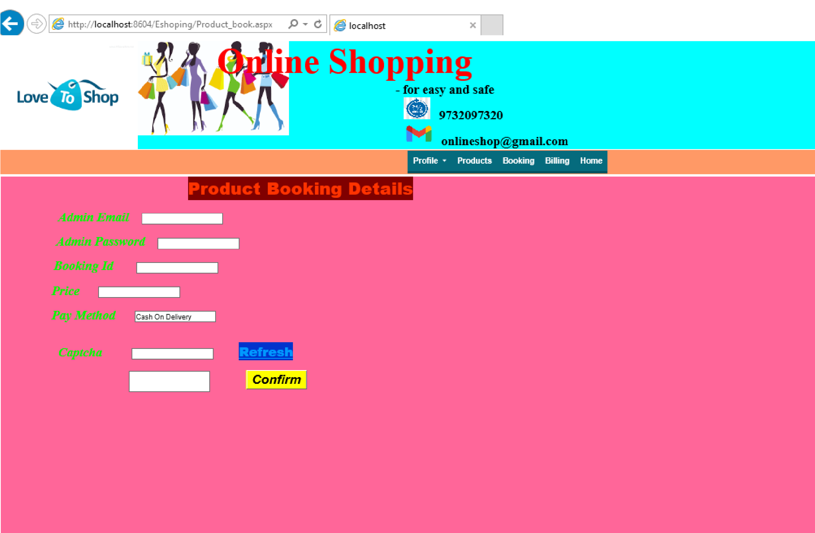

**SCOPE FOR IMPROVEMENT**

**I**n this system all the requirements have been added and implemented successfully. All the functionalities of the system have been working properly. Through the system has been implemented still there may be some more requirements that may come from the user. So for further improvement of the system can perform the following functionalities. The developed and previously tested functionalities can be modified later. With more user-friendly functions to make the system more useful.

Now the system is working on for the desktop computer and laptops. As the technology and requirements is changing day by day, we can add more functionality and we can implement the system with new requirements. The system is designed in such a way that it is flexible to change any further requirements prescribed by the Company.

✪ **CONCLUSION:**

**T**his project deals with all the necessary and essential events would handle approximately all kinds of purposes, occurred in the website is very necessary to operate systematically or computerized. In this cause we select this project. To implement this we have found a DBMS is the most wanted segment. We always keep in mind to develop such a DBMS project, which is affordable and can be implemented as for minimum existing stand-alone system.

We are not demanding that our project is bug free, but it can be implemented in as many segment users without any harm and feedback report can help further development and also it has portability and obviously so much user friendly.

Now a day’s time is measured with money. Therefore, it is luxury to spend our valuable tome to maintain the inventory system, when it will be handled automatically by computer.

But due to time constraints it was not possible to add extra features in our project.

Moreover, if someone wants to add more features, it is advised that one may further update it is in one’s way.

At last, I would like to extend my gratitude to all of my friends and well wishers who stood by me during entire project work.

## BIBLIOGRAPHY:

* **Books References:**

*1:* Programming Microsoft Visual Basic 2005

*Author:* ***Francesco Balena***

*2:* Programming VB.NET*.*

*Author:* ***Gary Cornell, Jonathan Morrison***

*3:* Professional VB.NET

*Author:* ***Bill Evjen et all***

* **Site References:**

* http://www.sartransport.com/custom-clearance-services.html

* http://www.indiamart.com/nscargomovers/enquiry.html?pname=EXIM%20Services

* http://www.sallogistics.com/services.html

* http://www.paramcargo.com/

* http://inspire.tradeindia.com/

* http://transportation.exportersindia.com/shipping-services/container-services.htm

* http://www.thaicargo.com/index.asp

* http://sso.gati.net

* http://www.freight-calculator.com/apxocean.asp

